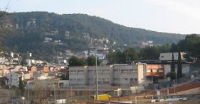

POMPEU

MATES

5

POMPEU MATES
5

ÀNGEL PORTA I RIBALTA

CURS 2005 - 2006
ÍNDEX

- Addició i subtracció | 3
- Multiplicació | 11
- Divisió I | 20
- Geometria | 28
- Divisió II | 34
- Decimals I | 40
- Decimals II | 45
- Fraccions | 50

- Sumem centenes

 | 5 | 8 | 9 |  |  | 4 | 6 | 7 |  |  | 8 | 8 | 9 |  |  | 2 | 3 | 7
+ | 7 | 5 | 9 |  | + | 1 | 9 | 9 |  | + | 2 | 7 | 9 |  | + | 4 | 6 | 8
 | 7 | 5 | 4 |  |  | 9 | 5 | 5 |  |  | 4 | 3 | 5 |  |  | 6 | 7 | 8
+ |  | 6 | 7 |  | + |  | 9 | 7 |  | + | 5 | 6 | 3 |  | + |  | 8 | 8
 | 5 | 8 | 4 |  |  | 8 | 0 | 4 |  |  | 1 | 7 | 5 |  |  | 3 | 6 | 8
+ | 4 | 7 | 9 |  | + | 4 | 6 | 7 |  | + |  | 2 | 5 |  | + | 8 | 3 | 6

- Sumem milers

 | 4 | 2 | 1 | 7 |  |  | 3 | 0 | 7 | 7 |  |  | 8 | 0 | 9 | 5 |  |  | 8 | 3 | 8 | 7
+ | 3 | 7 | 5 | 1 |  | + | 7 | 8 | 5 | 9 |  | + | 2 | 7 | 9 | 5 |  | + | 3 | 6 | 6 | 8
 | 7 | 5 | 0 | 4 |  |  | 5 | 8 | 9 | 9 |  |  | 4 | 6 | 5 | 2 |  |  | 1 | 8 | 5 | 9
+ |  | 9 | 7 | 5 |  | + | 6 | 7 | 3 | 3 |  | + | 1 | 9 | 0 | 9 |  | + | 3 | 7 | 8 | 9
 | 2 | 4 | 0 | 5 |  |  | 9 | 7 | 0 | 8 |  |  | 2 | 7 | 6 | 2 |  |  | 4 | 3 | 2 | 6
+ | 4 | 6 | 8 | 8 |  | + |  | 6 | 6 | 6 |  | + | 7 | 5 | 9 | 9 |  | + | 7 | 6 | 4 | 1

- Suma. Després canvia l’ordre dels sumands i torna a fer les sumes:

- 6812 + 2683 = | - 5214 + 3649 =
- 807 + 7937 = | - 3765 + 589 =
- 1957 + 1349 = | - 3765 + 3074 =
- 2812 + 3084 = | - 1265 + 5386 =

- Sumes de nombres de 5 i 6 xifres

 | 4 | 2 | 1 | 7 | 8 |  |  |  | 8 | 0 | 9 | 5 | 3 |  |  |  | 7 | 5 | 0 | 4 | 7
+ | 3 | 7 | 5 | 1 | 2 |  |  | + | 2 | 7 | 9 | 5 | 7 |  |  | + |  | 9 | 7 | 5 | 5
 | 5 | 8 | 9 | 9 | 6 |  |  |  | 1 | 8 | 5 | 9 | 1 |  |  |  | 9 | 7 | 0 | 8 | 8
+ | 6 | 7 | 3 | 3 | 5 |  |  | + | 3 | 7 | 8 | 9 | 8 |  |  | + |  | 6 | 6 | 6 | 2
 | 2 | 7 | 6 | 2 | 9 |  |  |  | 1 | 9 | 5 | 7 | 6 |  |  |  | 2 | 8 | 1 | 2 | 9
+ | 7 | 5 | 9 | 9 | 8 |  |  | + | 1 | 3 | 4 | 9 | 4 |  |  | + | 3 | 0 | 8 | 4 | 5

- Sumes de més de dos sumands

 | 4 | 3 |  |  | 3 | 5 |  |  | 2 | 3 | 2 |  |  | 4 | 0 | 5
 | 6 | 4 |  |  | 8 | 4 |  |  | 5 | 7 | 2 |  |  |  | 4 | 6
+ | 3 | 3 |  | + | 2 | 7 |  | + | 6 | 3 | 7 |  | + | 6 | 9 | 1

 | 3 | 5 | 1 |  |  | 6 | 6 | 1 |  |  | 7 | 1 | 6 | 8 |  |  |  | 5 | 3 | 2
 | 2 | 8 | 5 |  |  | 8 | 3 | 5 |  |  | 2 | 2 | 7 | 9 |  |  | 7 | 0 | 5 | 3
+ |  | 2 | 8 |  | + | 9 | 7 | 6 |  | + | 4 | 5 | 1 | 2 |  | + | 4 | 3 | 6 | 8

 | 4 | 5 | 2 | 3 | 1 | 6 |  |  |  | 4 | 0 | 6 | 5 | 4 |  |  | 3 | 7 | 2 | 2 | 6 | 0
 |  | 2 | 0 | 1 | 5 | 4 |  |  | 5 | 3 | 2 | 1 | 2 | 8 |  |  | 2 | 0 | 6 | 5 | 3 | 4
+ | 5 | 0 | 9 | 4 | 6 | 2 |  | + | 3 | 3 | 7 | 5 | 1 | 2 |  | + | 6 | 4 | 8 | 2 | 3 | 5

 |  | 7 | 2 | 3 | 6 | 5 |  |  | 2 | 6 |  |  | 6 | 8 |  |  | 1 | 7 |  |  | 6 | 5
 | 4 | 4 | 2 | 1 | 7 | 8 |  |  | 5 | 4 |  |  | 3 | 2 |  |  | 3 | 5 |  |  | 3 | 9
+ |  | 3 | 4 | 5 | 0 | 1 |  |  | 1 | 2 |  |  | 2 | 5 |  |  | 8 | 1 |  |  | 5 | 4
 |  |  |  |  |  |  |  | + | 3 | 1 |  | + | 5 | 6 |  | + | 4 | 6 |  | + | 2 | 1

- 56712 + 23563 + 212437 =

- 507973 + 3953 + 19605 + 457 =

- Restem centenes

 | 5 | 4 | 9 |  |  | 4 | 6 | 7 |  |  | 8 | 3 | 9 |  |  | 7 | 3 | 9
- | 1 | 5 | 2 |  | - | 1 | 9 | 2 |  | - | 2 | 7 | 9 |  | - | 4 | 6 | 8
 | 7 | 5 | 4 |  |  | 9 | 4 | 8 |  |  | 5 | 6 | 3 |  |  | 6 | 7 | 8
- |  | 6 | 2 |  | - |  | 9 | 7 |  | - | 4 | 3 | 5 |  | - |  | 8 | 8
 | 5 | 8 | 4 |  |  | 8 | 0 | 4 |  |  | 9 | 1 | 5 |  |  | 6 | 9 | 5
- | 4 | 7 | 0 |  | - | 4 | 6 | 3 |  | - | 5 | 7 | 4 |  | - | 5 | 8 | 1

 | 5 | 0 | 1 |  |  | 4 | 6 | 7 |  |  | 8 | 8 | 9 |  |  | 4 | 6 | 8
- | 2 | 5 | 9 |  | - | 1 | 9 | 9 |  | - | 2 | 7 | 9 |  | - | 2 | 0 | 7
 | 7 | 5 | 4 |  |  | 9 | 5 | 5 |  |  | 9 | 0 | 5 |  |  | 7 | 6 | 8
- |  | 6 | 7 |  | - |  | 9 | 7 |  | - | 5 | 6 | 3 |  | - |  | 8 | 8
 | 5 | 8 | 4 |  |  | 8 | 0 | 4 |  |  | 8 | 5 | 5 |  |  | 7 | 3 | 5
- | 2 | 7 | 9 |  | - | 4 | 6 | 5 |  | - |  | 9 | 7 |  | - | 4 | 6 | 3

- Restem milers

 | 5 | 4 | 9 | 4 |  |  | 4 | 6 | 7 | 5 |  |  | 8 | 3 | 9 | 9 |  |  | 7 | 3 | 9 | 5
- | 1 | 5 | 2 | 2 |  | - | 1 | 9 | 2 | 1 |  | - | 2 | 7 | 9 | 3 |  | - | 4 | 6 | 8 | 2
 | 9 | 0 | 8 | 8 |  |  | 4 | 1 | 5 | 6 |  |  | 4 | 0 | 0 | 0 |  |  | 5 | 0 | 0 | 1
- |  | 9 | 7 | 7 |  | - | 1 | 6 | 4 | 2 |  | - |  | 8 | 2 | 3 |  | - | 4 | 9 | 0 | 2
 | 8 | 4 | 0 | 0 |  |  | 4 | 0 | 5 | 0 |  |  | 1 | 0 | 0 | 0 |  |  | 9 | 0 | 0 | 7
- |  | 7 | 2 | 4 |  | - | 2 | 7 | 1 | 3 |  | - |  | 8 | 5 | 1 |  | - | 4 | 7 | 0 | 2

- Restes de nombres de 5 i 6 xifres

 | 7 | 1 | 1 | 0 | 1 |  |  |  | 5 | 0 | 7 | 0 | 6 |  |  |  | 5 | 4 | 8 | 3 | 0
- | 1 | 8 | 2 | 0 | 2 |  |  | - | 2 | 9 | 2 | 1 | 9 |  |  | - | 1 | 4 | 4 | 6 | 1
 | 7 | 0 | 9 | 5 | 5 |  |  |  | 4 | 0 | 5 | 0 | 2 |  |  |  | 7 | 0 | 1 | 2 | 1
- | 4 | 6 | 8 | 2 | 2 |  |  | - |  | 9 | 4 | 5 | 6 |  |  | - | 1 | 1 | 6 | 7 | 8
 | 3 | 0 | 5 | 8 | 2 |  |  |  | 5 | 8 | 4 | 0 | 0 |  |  |  | 7 | 1 | 3 | 2 | 1
- |  | 4 | 5 | 2 | 3 |  |  | - | 4 | 9 | 0 | 2 | 2 |  |  | - |  | 6 | 6 | 5 | 8
 | 3 | 2 | 4 | 3 | 2 |  |  |  | 1 | 7 | 6 | 0 | 7 |  |  |  | 9 | 0 | 0 | 7 | 7
- | 1 | 7 | 5 | 4 | 3 |  |  | - |  | 8 | 5 | 1 | 1 |  |  | - | 4 | 7 | 0 | 2 | 2

- Parèntesis

- (4320 – 3509) + 2361 = | - (32970 + 3703) + 1907 =
- (2607 + 1294) + 3802 = | - (18945 – 1653) – 867 =
- 7456 – (1008 + 3815) = | - 4520 + (23091 – 1583) =
- 2530 + (6000 – 1970) = | - (6560 – 1792) + 21342 =

- Multipliquem agrupant unitats, desenes i centenes

 | 2 | 6 | 3 |  |  | 1 | 3 | 4 |  |  | 4 | 1 | 7 |  |  | 3 | 6 | 4 |  |  | 1 | 3 | 8
 | x |  | 5 |  |  | x |  | 7 |  |  | x |  | 3 |  |  | x |  | 6 |  |  | x |  | 4
 | 1 | 3 | 2 | x | 3 | = |  |  |  |  |  | 3 | 2 | 7 | x | 5 | =
 | 2 | 1 | 9 | x | 2 | = |  |  |  |  |  | 4 | 7 | 3 | x | 4 | =
 | 1 | 5 | 7 | x | 2 | = |  |  |  |  |  | 2 | 3 | 2 | x | 3 | =

 | 2 | 1 | 7 |  |  | 6 | 5 | 7 |  |  | 4 | 9 | 5 |  |  | 3 | 8 | 7 |  |  | 5 | 0 | 4
 | x |  | 4 |  |  | x |  | 5 |  |  | x |  | 4 |  |  | x |  | 3 |  |  | x |  | 2
 | 1 | 2 | 3 |  |  | 4 | 3 | 0 |  |  | 2 | 8 | 7 |  |  | 2 | 4 | 6 |  |  | 4 | 0 | 7
 | X |  | 5 |  |  | x |  | 9 |  |  | x |  | 5 |  |  | x |  | 2 |  |  | x |  | 7
 | 1 | 3 | 8 |  |  | 7 | 3 | 4 |  |  | 1 | 3 | 8 |  |  | 6 | 8 | 3 |  |  | 3 | 1 | 7
 | x |  | 3 |  |  | x |  | 8 |  |  | x |  | 6 |  |  | x |  | 5 |  |  | x |  | 8
 | 5 | 4 | 9 | x | 7 | = |  |  |  |  |  | 6 | 1 | 8 | x | 3 | =
 | 5 | 0 | 0 | x | 7 | = |  |  |  |  |  | 6 | 0 | 0 | x | 4 | =
 | 7 | 5 | 3 | x | 4 | = |  |  |  |  |  | 2 | 4 | 8 | x | 2 | =
- Multiplicació de nombres de 4, 5 o 6 xifres

 | 5 | 0 | 1 | 3 |  |  | 4 | 6 | 7 | 6 |  |  | 8 | 8 | 9 | 5 |  |  | 2 | 0 | 7 | 5
x |  |  |  | 4 |  | x |  |  |  | 3 |  | x |  |  |  | 9 |  | x |  |  |  | 5
 | 7 | 5 | 4 | 3 |  |  | 9 | 5 | 5 | 1 |  |  | 9 | 0 | 5 | 2 |  |  | 6 | 7 | 8 | 3
x |  |  |  | 2 |  | x |  |  |  | 6 |  | x |  |  |  | 3 |  | x |  |  |  | 8
 | 5 | 8 | 4 | 2 |  |  | 8 | 0 | 4 | 3 |  |  | 8 | 5 | 5 | 6 |  |  | 7 | 3 | 5 | 4
x |  |  |  | 3 |  | x |  |  |  | 5 |  | x |  |  |  | 7 |  | x |  |  |  | 3
 | 6 | 7 | 8 | 4 |  |  | 8 | 8 | 4 | 5 |  |  | 8 | 0 | 4 | 1 |  |  | 3 | 8 | 6 | 5
x |  |  |  | 4 |  | x |  |  |  | 9 |  | x |  |  |  | 7 |  | x |  |  |  | 6
 | 3 | 4 | 2 | 5 | 7 | x | 4 | =
 | 1 | 2 | 7 | 8 | 9 | x | 3 | =
 | 2 | 6 | 8 | 9 | 2 | x | 3 | =
 | 3 | 2 | 6 | 0 | 1 | x | 8 | =
 | 2 | 5 | 6 | 7 | 1 | x | 2 | =
 | 5 | 3 | 1 | 3 | 7 | x | 6 | =

- Multipliquem desenes

 | 8 | 1 |  |  |  | 4 | 6 | 7 |  |  |  | 7 | 0 | 0 |  |  |  | 2 | 2 | 0 | 7
x | 1 | 0 |  |  | x |  | 1 | 0 |  |  | x |  | 1 | 0 |  |  | x |  |  | 1 | 0
 | 5 | 4 |  |  |  | 9 | 5 | 5 |  |  |  | 9 | 0 | 5 | 5 | 5 |  |  |  |  | 4
x | 1 | 0 |  |  | x |  | 1 | 0 |  |  | x |  |  |  | 1 | 0 |  |  | x | 1 | 0
 | 1 | 0 | x | 5 | 6 | 3 | 0 | 7 | =
 | 1 | 0 | x | 7 | 5 | 0 | 0 | 0 | =
 | 1 | 0 | x | 6 | 0 | 3 | =
 | 1 | 0 | x | 6 | =
 | 1 | 0 | x | 3 | 6 | 4 | 0 | 0 | =
 | 1 | 0 | x | 3 | 2 | 6 | 7 | 3 | =

- Multipliquem per desenes

 | 9 | 5 |  |  |  | 8 | 3 | 2 |  |  |  | 9 | 0 | 0 |  |  |  | 5 | 3 | 1 | 3
x | 8 | 0 |  |  | x |  | 3 | 0 |  |  | x |  | 4 | 0 |  |  | x |  |  | 3 | 0
 | 8 | 0 |  |  |  | 9 | 5 | 5 |  |  |  | 4 | 0 | 5 | 0 | 0 |  |  |  | 7 | 4
x | 7 | 0 |  |  | x |  | 5 | 0 |  |  | x |  |  |  | 3 | 0 |  |  | x | 8 | 0
 | 8 | 3 | 2 | 4 | 3 | x | 3 | 0 | =
 | 7 | 0 | 0 | 3 | x | 4 | 0 | =
 | 2 | 6 | 0 | 4 | 2 | x | 6 | 0 | =
 | 6 | 3 | 7 | 0 | 9 | x | 6 | 0 | =
 | 7 | 3 | 2 | 5 | x | 5 | 0 | =
 | 3 | 5 | 3 | 1 | x | 7 | 0 | =

- Multiplicació de dues xifres

 | 9 | 5 |  |  |  | 8 | 3 | 2 |  |  |  | 9 | 0 | 0 |  |  |  | 5 | 3 | 1 | 3
x | 2 | 0 |  |  | x |  | 2 | 3 |  |  | x |  | 4 | 6 |  |  | x |  |  | 3 | 7
 | 8 | 0 |  |  |  | 9 | 5 | 5 |  |  |  | 4 | 0 | 5 | 0 | 0 |  |  |  | 7 | 4
x | 7 | 2 |  |  | x |  | 5 | 6 |  |  | x |  |  |  | 3 | 8 |  |  | x | 8 | 9
 | 8 | 3 | 2 | 4 | 3 | x | 3 | 6 | =
 | 2 | 6 | 0 | 4 | 2 | x | 6 | 7 | =
- Multipliquem centenes

 |  |  | 8 | 3 | 2 |  |  |  |  | 3 | 1 | 3 |  |  |  |  |  | 1 | 5 | 7 |  |  |  |  |  | 9 | 5 | 5
 |  | x | 2 | 0 | 0 |  |  |  | x | 3 | 0 | 0 |  |  |  |  | x | 9 | 0 | 0 |  |  |  |  | x | 2 | 0 | 0
 |  |  | 8 | 4 |  |  |  |  |  | 9 | 0 | 3 |  |  |  |  |  | 5 | 3 | 0 |  |  |  |  |  | 8 | 4 | 0
 | x | 7 | 0 | 0 |  |  |  |  | x | 2 | 0 | 0 |  |  |  |  | x | 3 | 0 | 0 |  |  |  |  | x | 5 | 0 | 0
 |  |  | 2 | 4 | 3 | x | 3 | 0 | 0 | =
 |  |  | 4 | 2 | x | 6 | 0 | 0 | =
 |  |  | 6 | 9 | 3 | x | 4 | 0 | 0 | =
 |  |  | 3 | 4 | x | 2 | 0 | 0 | =
 |  |  | 6 | 7 | 8 | 9 | 1 | x | 5 | 0 | 0 | =
- Multiplicació de nombres grans

 |  |  | 8 | 3 | 2 |  |  |  |  | 3 | 1 | 3 |  |  |  |  |  | 1 | 5 | 7 |  |  |  |  |  | 9 | 5 | 5
 |  | x | 2 | 4 | 7 |  |  |  | x | 3 | 5 | 2 |  |  |  |  | x | 9 | 5 | 3 |  |  |  |  | x | 2 | 6 | 1
 |  |  | 8 | 4 |  |  |  |  |  | 9 | 0 | 3 |  |  |  |  |  | 5 | 3 | 0 |  |  |  |  |  | 8 | 4 | 0
 | x | 7 | 1 | 6 |  |  |  |  | x | 2 | 0 | 7 |  |  |  |  | x | 3 | 6 | 7 |  |  |  |  | x | 5 | 8 | 0
 |  |  | 2 | 4 | 3 | x | 3 | 9 | 1 | =
 |  |  | 4 | 2 | x | 6 | 2 | 5 | =
- Arrodoniment de productes

 |  |  | 8 | 3 |  |  |  |  |  | 3 | 1 | 3 |  |  |  |  |  | 1 | 5 | 7 |  |  |  |  |  | 9 | 5 | 5
 |  | x | 2 | 4 |  |  |  |  | x |  | 5 | 2 |  |  |  |  | x |  | 6 | 3 |  |  |  |  | x |  | 6 | 7
 |  |  | 8 | 4 |  |  |  |  |  | 9 | 5 |  |  |  |  |  |  | 5 | 3 |  |  |  |  |  |  | 8 | 4
 |  | x | 1 | 6 |  |  |  |  | x | 2 | 0 |  |  |  |  |  | x | 3 | 6 |  |  |  |  |  | x | 5 | 5

- Divisió de nombres grans

8 | 3 | 2 | 3 |  |  |  |  | 7 | 6 | 5 | 2 |  |  |  |  | 6 | 9 | 4 | 3

9 | 4 | 4 | 8 |  |  |  |  | 7 | 0 | 6 | 4 |  |  |  |  | 6 | 3 | 2 | 5

4 | 3 | 2 | 2 |  |  |  |  | 4 | 0 | 5 | 3 |  |  |  |  | 8 | 0 | 0 | 6

7 | 1 | 2 | 6 |  |  |  |  | 6 | 7 | 5 | 2 |  |  |  |  | 9 | 2 | 0 | 7

- Quocients inferiors a 100

3 | 3 | 2 | 5 |  |  |  |  | 7 | 6 | 0 | 9 |  |  |  |  | 6 | 0 | 4 | 5

5 | 6 | 4 | 5 |  |  |  |  | 2 | 0 | 3 | 4 |  |  |  |  | 6 | 7 | 9 | 4

4 | 0 | 5 | 5 |  |  |  |  | 4 | 7 | 2 | 8 |  |  |  |  | 1 | 7 | 4 | 6

7 | 0 | 0 | 6 |  |  |  |  | 6 | 5 | 5 | 2 |  |  |  |  | 9 | 0 | 8 | 7

- Zeros en el quocient

4 | 0 | 2 | 2 |  |  |  |  | 9 | 2 | 7 | 3 |  |  |  |  | 3 | 2 | 0 | 8

9 | 0 | 9 | 3 |  |  |  |  | 3 | 0 | 6 | 3 |  |  |  |  | 6 | 0 | 0 | 5

9 | 0 | 7 | 3 |  |  |  |  | 4 | 0 | 5 | 8 |  |  |  |  | 8 | 0 | 0 | 4

7 | 0 | 2 | 3 |  |  |  |  | 6 | 0 | 5 | 5 |  |  |  |  | 8 | 2 | 0 | 4

- Divisions entre desenes

6 | 2 | 1 | 5 | 0 |  |  |  | 7 | 8 | 3 | 7 | 0 |  |  |  | 6 | 7 | 2 | 5 | 0

7 | 6 | 4 | 5 | 0 |  |  |  | 5 | 3 | 2 | 4 | 0 |  |  |  | 6 | 5 | 2 | 4 | 0

6 | 4 | 2 | 5 | 0 |  |  |  | 9 | 7 | 2 | 8 | 0 |  |  |  | 7 | 0 | 7 | 6 | 0

7 | 8 | 3 | 6 | 0 |  |  |  | 4 | 6 | 5 | 2 | 0 |  |  |  | 8 | 4 | 8 | 7 | 0

- Més divisions

6 | 2 | 1 | 2 | 7 |  |  |  | 7 | 8 | 3 | 3 | 6 |  |  |  | 6 | 7 | 2 | 3 | 6

7 | 6 | 4 | 2 | 7 |  |  |  | 5 | 3 | 2 | 3 | 6 |  |  |  | 6 | 5 | 2 | 2 | 7

6 | 4 | 2 | 2 | 7 |  |  |  | 9 | 7 | 2 | 3 | 6 |  |  |  | 8 | 5 | 6 | 2 | 7

- Arrodoniment del divisor

6 | 2 | 7 | 2 | 1 |  |  |  | 7 | 0 | 3 | 3 | 2 |  |  |  | 4 | 7 | 2 | 4 | 5
6 | 2 | 7 |  |  |  |  |  | 7 | 0 | 3 |  |  |  |  |  | 4 | 7 | 2

5 | 6 | 4 | 2 | 4 |  |  |  | 5 | 3 | 9 | 2 | 3 |  |  |  | 6 | 1 | 2 | 3 | 1
5 | 6 | 4 |  |  |  |  |  | 5 | 3 | 9 |  |  |  |  |  | 6 | 1 | 2

6 | 4 | 0 | 2 | 6 |  |  |  | 9 | 0 | 2 | 2 | 5 |  |  |  | 6 | 3 | 2 | 1 | 8
6 | 4 | 0 |  |  |  |  |  | 9 | 0 | 2 |  |  |  |  |  | 6 | 3 | 2

1 | 5 | 2 | 2 | 6 |  |  |  | 5 | 4 | 2 | 3 | 1 |  |  |  | 8 | 7 | 2 | 4 | 0
1 | 5 | 2 |  |  |  |  |  | 5 | 4 | 2 |  |  |  |  |  | 8 | 7 | 2

GEOMETRIA

- Observa:

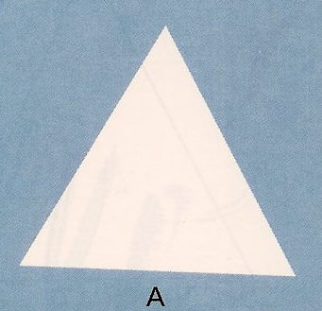 | 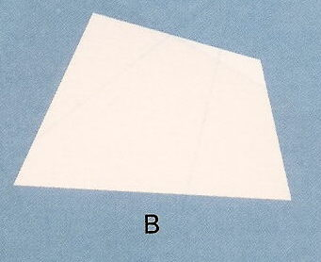 | 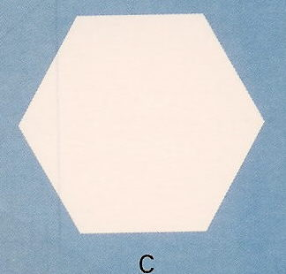 | 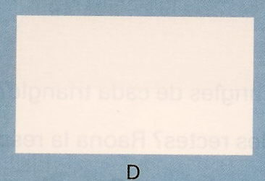 | 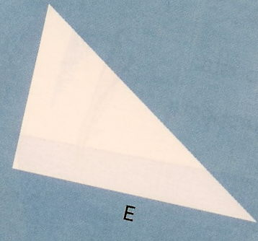
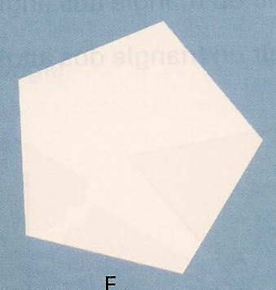 | 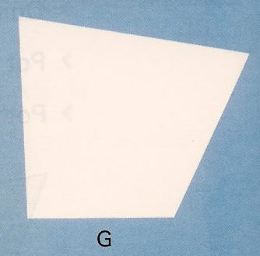 | 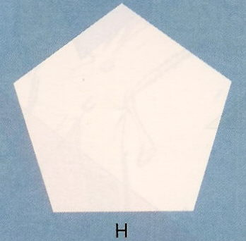 |  | 

POLÍGONS | A | B | C | D | E | F | G | H | I | J
Quins polígons tenen 3 costats?
Quins polígons són triangles?
Quins polígons tenen 4 costats?
Quins polígons són quadrilàters?
Quins polígons tenen 5 costats?
Quins polígons són pentàgons?
Quins polígons tenen 6 costats?
Quins polígons són hexàgons?
Quants angles tenen?

- Un polígon té més angles que costats?

- Observa:

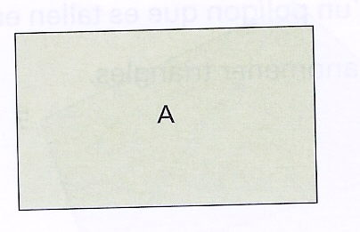 | 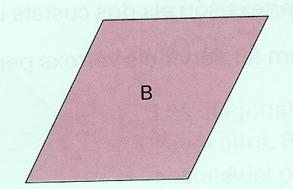 | 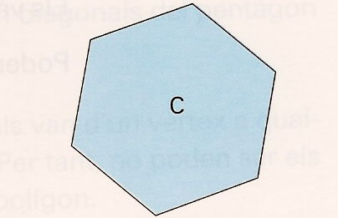 | 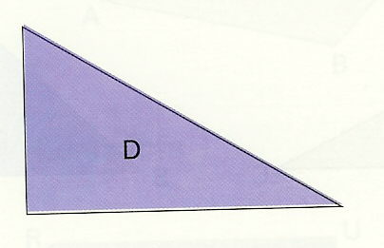
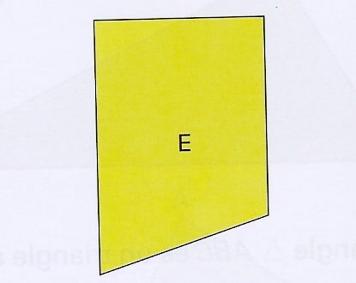 | 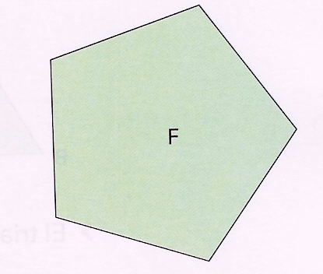 | 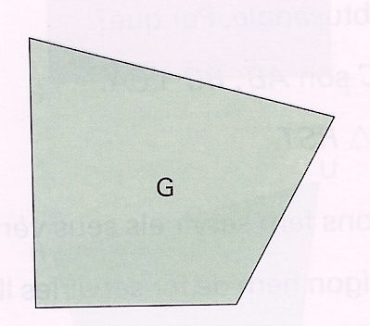 | 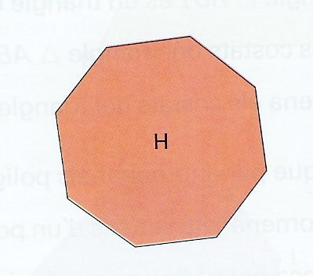
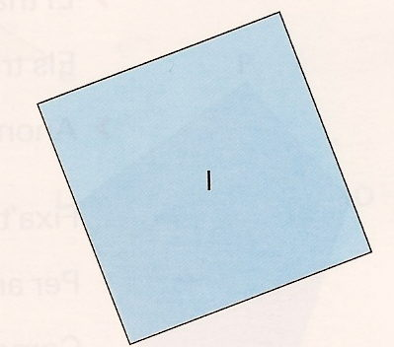 | 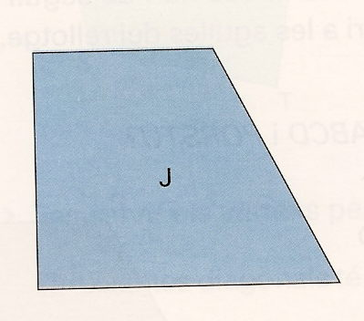 | 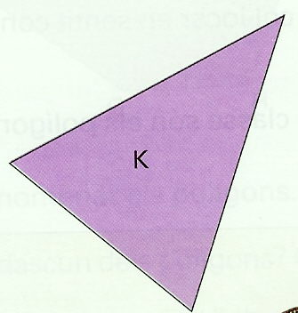 | 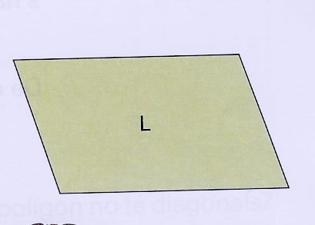

POLÍGONS | A | B | C | D | E | F | G | H | I | J | K | L
Quins polígons són triangles?
Quins polígons són quadrilàters?
Quins polígons són rectangles?
Quins polígons són quadrats?
Són rectangles però no quadrats?
Quins polígons són pentàgons?
Quins polígons són hexàgons?

- Observa:

A | B | C | D | E
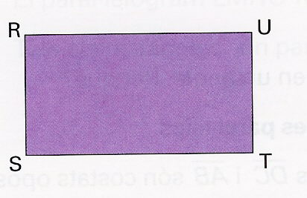 | 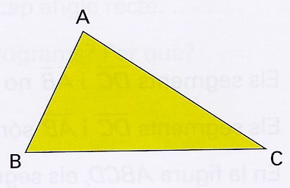 | 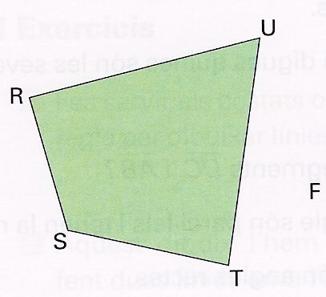 | 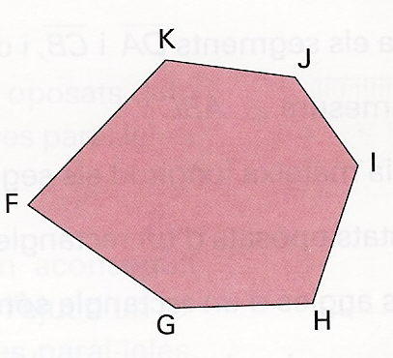 | 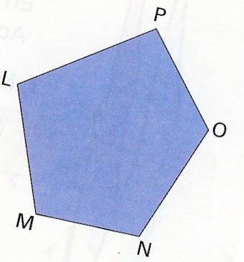

POLÍGONS | A | B | C | D | E
Quantes diagonals té cadascun dels polígons?

- Quin polígon no té diagonals?

- Anomena els costats de l’hexàgon FGHIJK.

- Anomena les diagonals del pentàgon LMNOP.

- Completa la taula següent:

Nombre de costats | Nombre de diagonals
3 | 0
4
5
6

- Observa:

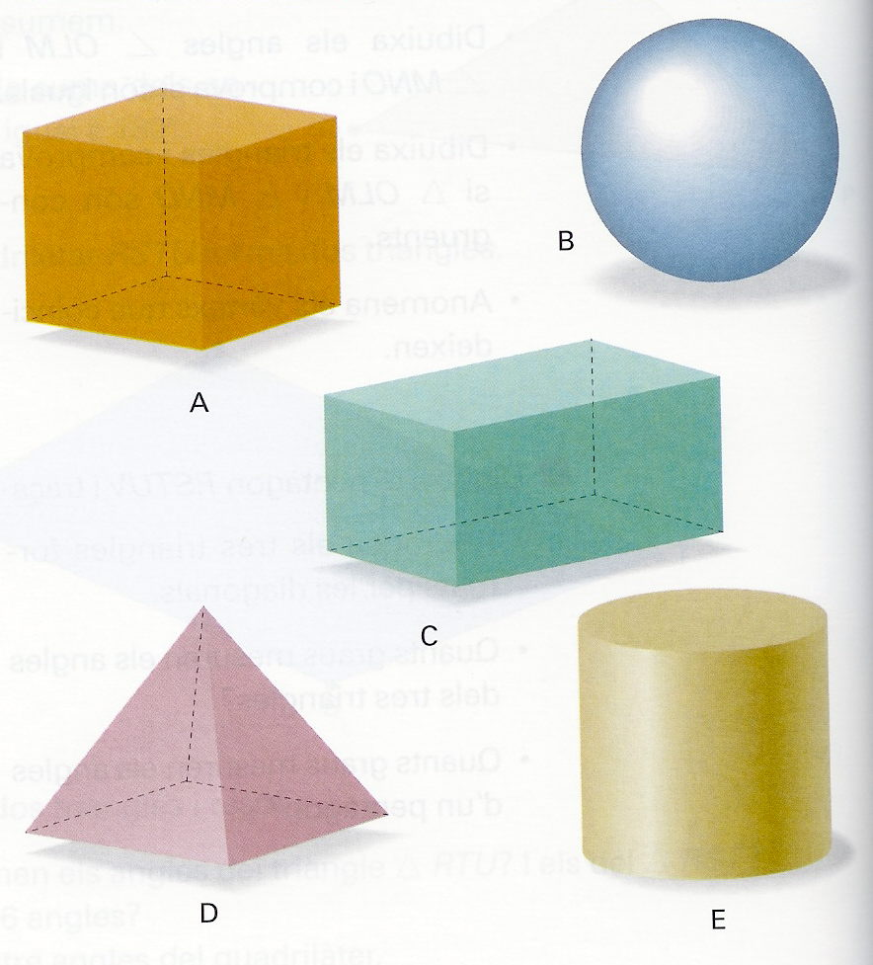

Figures tridimensionals | A | B | C | D | E
Esfera
Cilindre
Cub
Prisma
Piràmide

- Observa:

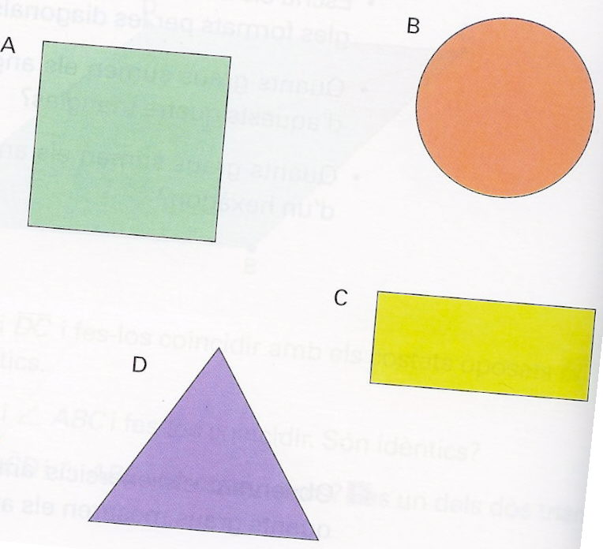

Figures planes | A | B | C | D
Quadrat
Rectangle
Cercle
Triangle
- Observa:

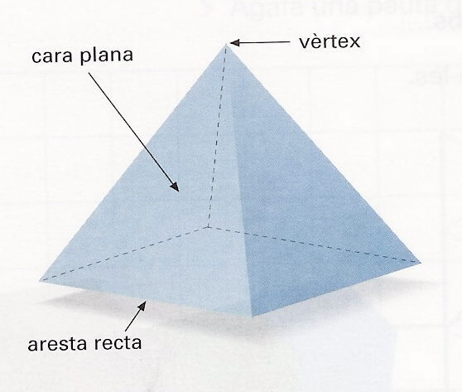 | Arestes rectes
 | Arestes corbes
 | Cares planes
 | Cares corbes
 | vèrtexs
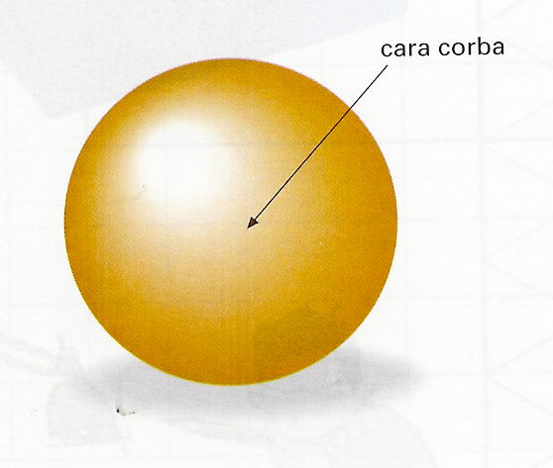 | Arestes rectes
 | Arestes corbes
 | Cares planes
 | Cares corbes
 | vèrtexs
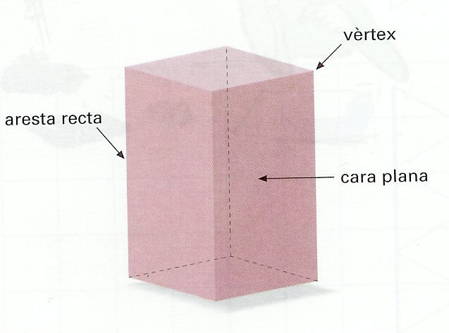 | Arestes rectes
 | Arestes corbes
 | Cares planes
 | Cares corbes
 | vèrtexs
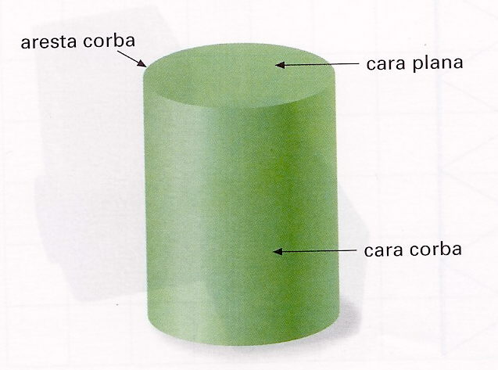 | Arestes rectes
 | Arestes corbes
 | Cares planes
 | Cares corbes
 | vèrtexs

- Divisió de nombres de moltes xifres

3 | 0 | 0 | 3 | 5 |  |  |  | 2 | 8 | 0 | 2 | 7 |  |  |  | 5 | 0 | 0 | 8 | 7

2 | 0 | 4 | 4 | 5 |  |  |  | 5 | 3 | 2 | 5 | 8 |  |  |  | 6 | 5 | 2 | 3 | 7

6 | 4 | 2 | 4 | 7 |  |  |  | 1 | 7 | 1 | 0 | 8 |  |  |  | 7 | 0 | 7 | 6 | 9

2 | 8 | 3 | 4 | 4 |  |  |  | 4 | 6 | 0 | 5 | 6 |  |  |  | 3 | 4 | 0 | 8 | 9

1 | 0 | 7 | 5 | 3 |  |  |  | 5 | 8 | 3 | 6 | 6 |  |  |  | 2 | 6 | 5 | 4 | 3
- Dividim entre desenes

4 | 0 | 5 | 2 | 5 | 0 |  | 2 | 3 | 5 | 2 | 5 | 7 | 0 |  |  | 4 | 2 | 0 | 0 | 0 | 5 | 0

3 | 1 | 8 | 0 | 5 | 0 |  | 5 | 0 | 2 | 0 | 5 | 8 | 0 |  |  |  | 4 | 4 | 6 | 4 | 7 | 0

7 | 7 | 7 | 7 | 8 | 0 |  | 2 | 6 | 6 | 0 | 9 | 6 | 0 |  |  | 1 | 1 | 0 | 7 | 5 | 3 | 0

8 | 1 | 0 | 9 | 9 | 0 |  | 3 | 5 | 2 | 0 | 5 | 6 | 0 |  |  | 2 | 1 | 0 | 5 | 7 | 3 | 0

3 | 6 | 0 | 7 | 4 | 0 |  | 3 | 5 | 5 | 1 | 3 | 7 | 0 |  |  |  | 2 | 0 | 2 | 0 | 7 | 0
- Dividim arrodonint el dividend i el divisor

3 | 3 | 2 | 2 | 5 | 1 |  | 4 | 3 | 1 | 0 | 5 | 7 | 2 |  |  | 3 | 1 | 0 | 7 | 0 | 4 | 4

2 | 1 | 6 | 0 | 6 | 3 |  | 6 | 2 | 4 | 0 | 5 | 8 | 2 |  |  | 2 | 5 | 1 | 0 | 3 | 4 | 4

- Més divisions per arrodoniment

8 | 0 | 3 | 2 | 5 | 7 |  | 7 | 5 | 1 | 4 | 5 | 7 | 8 |  |  | 5 | 0 | 4 | 5 | 6 | 8 | 6

7 | 2 | 8 | 2 | 6 | 8 |  | 5 | 1 | 5 | 7 | 9 | 4 | 9 |  |  |  | 5 | 7 | 2 | 8 | 2 | 6

- Divisió de nombres de més de dues xifres

3 | 0 | 0 | 3 | 2 | 8 | 2 | 4 | 6 |  |  |  | 6 | 1 | 0 | 2 | 2 | 0 | 7 | 1 | 3 | 4

5 | 3 | 2 | 5 | 6 | 5 | 3 | 4 | 8 |  |  |  | 6 | 4 | 2 | 4 | 1 | 7 | 9 | 8 | 5 | 2

1 | 0 | 7 | 5 | 5 | 8 | 7 | 8 | 6 |  |  |  | 7 | 0 | 7 | 6 | 2 | 8 | 2 | 4 | 5 | 8

8 | 7 | 6 | 9 | 8 | 7 | 3 | 6 | 8 |  |  |  | 8 | 7 | 4 | 5 | 6 | 3 | 5 | 1 | 2 | 9

- Arrodoneix els nombres següents a les centèsimes.

- 23,678 | - 0,658
- 5,629 | - 105,071
- 0,017 | - 101,901
- 0,654 | - 1,573

- Arrodoneix els nombres següents a les dècimes.

- 3,738 | - 0,172
- 100,609 | - 35,497
- 4,671 | - 56,432
- 8,018 | - 10,013

- Arrodoneix els nombres següents a les unitats.

- 3,953 | - 17,328
- 32,67 | - 9,608
- 213,356 | - 5,6
- 0,608 | - 50,299

- Suma de nombres decimals

 | 7, | 2 | 5 | 9 |  |  | 0, | 2 | 2 | € |  |  | 2, | 3 | 2 | 5 |  |  | 0, | 2 | 8 | 7
+ | 5, | 0 | 8 | 8 |  | + | 5, | 9 | 3 | € |  | + | 0, | 2 | 9 | 6 |  | + | 0, | 4 | 6 | 3

 | 2, | 2 | 0 | 0 |  |  | 0, | 2 | 0 | € |  |  | 6, | 2 | 1 | 1 |  |  | 0, | 7 | 0 | 9
+ | 1, | 6 | 7 | 8 |  | + | 3, | 5 | 5 | € |  | + | 3, | 4 | 7 | 9 |  | + | 3, | 1 | 3 | 2

 | 7, | 2 | 0 | 1 |  |  | 2, | 1 | 0 | € |  |  | 0, | 7 | 2 | 5 |  |  | 9, | 0 | 0 | 1
+ | 8, | 3 | 8 | 2 |  | + | 5, | 4 | 0 | € |  | + | 1, | 4 | 2 | 2 |  | + | 3, | 0 | 0 | 9

 | 7, | 2 | 0 | 5 |  |  | 2, | 2 | 0 | € |  |  | 0, | 2 | 5 | 0 |  |  | 1, | 6 | 2 | 2
+ | 0, | 4 | 6 | 2 |  | + | 4, | 5 | 0 | € |  | + | 9, | 9 | 9 | 9 |  | + | 9, | 4 | 8 | 8

 | 0, | 2 | 0 | € | + | 0, | 7 | 5 | € | =
 | 0, | 2 | 7 | 6 | + | 2, | 3 | 1 | 7 | + | 6, | 3 | 0 | 2 | =
 | 3, | 0 | 1 | 6 | + | 5, | 4 | 0 | 9 | =
 | 3, | 2 | 0 | € | + | 0, | 4 | 0 | € | + | 2, | 6 | 0 | € | =
- Resta de nombres decimals

 | 7, | 2 | 5 | 9 |  |  | 5, | 2 | 2 | € |  |  | 2, | 3 | 2 | 6 |  |  | 8, | 2 | 0 | 7
- | 4, | 0 | 8 | 9 |  | - | 5, | 1 | 1 | € |  | - | 0, | 2 | 9 | 6 |  | - | 0, | 5 | 6 | 9

 | 2, | 2 | 0 | 0 |  |  | 3, | 5 | 5 | € |  |  | 6, | 0 | 1 | 1 |  |  | 8, | 7 | 0 | 6
- | 1, | 6 | 7 | 8 |  | - | 0, | 2 | 0 | € |  | - | 3, | 4 | 8 | 9 |  | - | 3, | 0 | 3 | 7

 | 9, | 2 | 0 | 1 |  |  | 9, | 1 | 0 | € |  |  | 4, | 7 | 0 | 0 |  |  | 7, | 0 | 0 | 8
- | 8, | 6 | 0 | 2 |  | - | 4, | 3 | 0 | € |  | - | 1, | 0 | 3 | 2 |  | - | 3, | 5 | 5 | 9

 | 7, | 2 | 0 | 1 |  |  | 6, | 2 | 0 | € |  |  | 2, | 2 | 0 | 2 |  |  | 7, | 1 | 0 | 2
- | 2, | 4 | 0 | 1 |  | - | 3, | 5 | 0 | € |  | - | 0, | 8 | 7 | 8 |  | - | 2, | 4 | 8 | 1

 | 5, | 3 | 5 | € | - | 0, | 7 | 5 | € | =
 | 7, | 2 | 0 | 6 | - | 2, | 3 | 1 | 8 | =
 | 6, | 0 | 0 | 6 | - | 5, | 0 | 0 | 7 | =
 | 4, | 1 | 0 | € | - | 0, | 5 | 0 | € | =

- Multiplicació de nombres decimals

 | 6 | 4, | 3 | 5 |  |  | 6, | 4 | 3 | 5 |  |  | 6 | 4, | 3 | 5 |  |  | 6 | 4 | 3, | 5

 | x | 0, | 3 | 4 |  |  | x |  | 3, | 4 |  |  | x |  | 3, | 4 |  |  | x | 0, | 3 | 4

 | 6, | 4 | 3 | 5 |  |  | 6 | 4 | 3, | 5 |  |  | 6 | 4 | 3, | 5 |  |  | 6 | 4, | 3 | 5

 | x |  | 3 | 4 |  | x | 0, | 0 | 3 | 4 |  |  | x |  | 3, | 4 |  |  | x |  | 3 | 4

- Divisió de decimals

6 | 3, | 2 | 1 | 3 |  |  |  |  | 3, | 8 | 6 | 8 | 2 |  |  |  |  | 7, | 0 | 2 | 3

5, | 3 | 1 | 5 | 5 |  |  |  |  | 6 | 1 | 2, | 5 | 5 |  |  |  |  | 5, | 6 | 4 | 2

6, | 4 | 0 | 2 | 2 |  |  |  |  | 9 | 0, | 3 | 5 | 5 |  |  |  |  | 6, | 2 | 7 | 3

5, | 4 | 0 | 6 | 3 |  |  |  |  | 8, | 7 | 6 | 0 | 4 |  |  |  |  | 4 | 7, | 2 | 4

4, | 0 | 7 | 2 | 2 |  |  |  |  | 3 | 5 | 2, | 6 | 6 |  |  |  |  | 7 | 4, | 2 | 6
- Zeros

5, | 1 | 1 | 2 | 6 |  |  |  |  | 0, | 1 | 2 | 5 | 5 |  |  |  |  | 0, | 2 | 7 | 3

6, | 3 | 9 | 2 | 8 |  |  |  |  | 0, | 3 | 5 | 2 | 4 |  |  |  |  | 0, | 2 | 4 | 6

3, | 2 | 0 | 8 | 4 |  |  |  |  | 3, | 8 | 6 | 8 | 4 |  |  |  |  | 5, | 6 | 4 | 8

5, | 4 | 0 | 4 | 7 |  |  |  |  | 8, | 7 | 5 | 7 | 9 |  |  |  |  | 7, | 2 | 0 | 4

0, | 0 | 7 | 2 | 2 |  |  |  |  | 0, | 9 | 3 | 1 | 7 |  |  |  |  | 7 | 4, | 2 | 6
- Divisions de nombres decimals no exactes

7, | 1 | 1 | 2 | 6 |  |  |  |  | 2, | 3 | 5 | 6 | 4 |  |  |  |  | 0, | 2 | 6 | 3

2, | 4 | 0 | 4 | 7 |  |  |  |  | 0, | 4 | 5 | 2 | 2 |  |  |  |  | 5, | 6 | 2 | 8

7 | 4, | 2 | 3 | 6 |  |  |  |  | 3 | 1, | 5 | 0 | 8 |  |  |  |  | 0, | 1 | 3 | 4

6, | 3 | 9 | 0 | 3 |  |  |  |  | 3, | 4 | 1 | 0 | 2 |  |  |  |  | 3, | 8 | 2 | 9

0, | 9 | 3 | 0 | 7 |  |  |  |  | 0, | 2 | 5 | 0 | 6 |  |  |  |  | 8, | 7 | 5 | 5
- Més divisions de nombres decimals no exactes

- Busca el quocient i el residu d’aquestes divisions.

2 | 8 | 3 |  |  |  | 6 | 2 | 8 |  |  |  | 2 | 5 | 6 |  |  |  | 7 | 2 | 4

- Busca el quocient d’aquestes divisions i arrodoneix-lo a les centèsimes.

3 | 7 | 6 |  |  |  |  | 1 | 3 | 4 |  |  |  |  | 3 | 9 | 8 |  |  |  |  | 5 | 6 | 9

4 | 1 | 6 |  |  |  |  | 6 | 2 | 9 |  |  |  |  | 4 | 0 | 6 |  |  |  |  | 7 | 5 | 7

5 | 2 | 7 |  |  |  |  | 9 | 3 | 7 |  |  |  |  | 2 | 3 | 4 |  |  |  |  | 3 | 5 | 8

- Fraccions equivalents

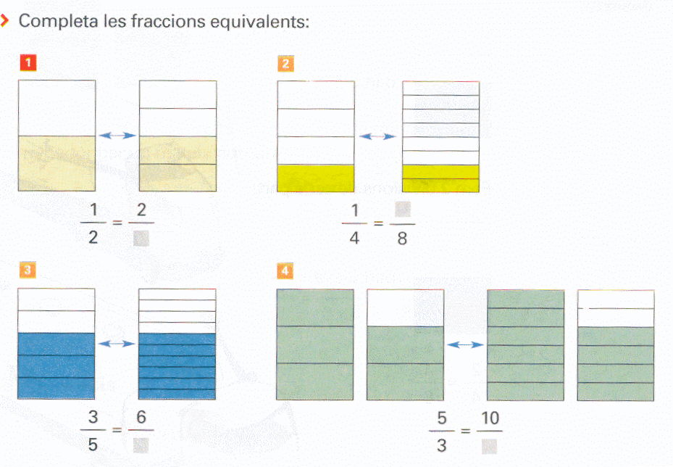

$$\frac{1}{2}\text{ = }\frac{2}{}$$ | $$\frac{1}{4}\text{ = }\frac{}{8}$$
$$\frac{3}{5}\text{ = }\frac{6}{}$$ | $$\frac{5}{3}\text{ = }\frac{\text{10}}{}$$

- Multipliquem per obtenir fraccions equivalents
- Completa aquestes igualtats:

$$\frac{8}{7}\text{ = }\frac{\text{3 x }}{\text{7 x 5}}\text{ = }\frac{}{\text{35}}$$ | $$\frac{2}{5}\text{ = }\frac{\text{2 x }}{\text{5 x 9}}\text{ = }\frac{}{\text{45}}$$ | $$\frac{9}{5}\text{ = }\frac{\text{9 x }}{\text{5 x 3}}\text{ = }\frac{}{\text{15}}$$
$$\frac{3}{5}\text{ = }\frac{\text{3 x 4}}{\text{5 x }}\text{ = }\frac{\text{12}}{}$$ | $$\frac{4}{5}\text{ = }\frac{\text{4 x 2}}{\text{5 x }}\text{ = }\frac{8}{}$$ | $$\frac{7}{2}\text{ = }\frac{\text{7 x 5}}{\text{2 x }}\text{ = }\frac{\text{35}}{}$$
$$\frac{3}{7}\text{ = }\frac{\text{3 x }}{\text{7 x 2}}\text{ = }\frac{}{\text{14}}$$ | $$\frac{5}{8}\text{ = }\frac{\text{5 x }}{\text{8 x 5}}\text{ = }\frac{}{\text{40}}$$ | $$\frac{6}{5}\text{ = }\frac{\text{6 x }}{\text{5 x 4}}\text{ = }\frac{}{\text{20}}$$
$$\frac{1}{6}\text{ = }\frac{\text{1 x }}{\text{6 x 7}}\text{ = }\frac{}{\text{42}}$$ | $$\frac{9}{7}\text{ = }\frac{\text{9 x 5}}{\text{7 x }}\text{ = }\frac{\text{45}}{}$$ | $$\frac{4}{9}\text{ = }\frac{\text{4 x }}{\text{9 x 6}}\text{ = }\frac{}{\text{54}}$$
$$\frac{7}{8}=\frac{\text{56}}{}$$ | $$\frac{1}{5}=\frac{}{\text{15}}$$ | $$\frac{7}{2}=\frac{\text{42}}{}$$
$$\frac{2}{3}=\frac{}{\text{15}}$$ | $$\frac{5}{9}=\frac{\text{25}}{}$$ | $$\frac{5}{4}=\frac{}{\text{20}}$$

- Dividim per obtenir fraccions equivalents
- Divideix i busca les fraccions equivalents:

$$\frac{4}{8}\text{ = }\frac{\text{4 : }}{\text{8 : 2}}\text{ = }\frac{}{4}$$ | $$\frac{5}{\text{10}}\text{ = }\frac{\text{5 : }}{\text{10 : 5}}\text{ = }\frac{}{2}$$ | $$\frac{9}{6}\text{ = }\frac{\text{9 : }}{\text{6 : 3}}\text{ = }\frac{}{2}$$
$$\frac{3}{\text{15}}\text{ = }\frac{\text{ 3 : 3 }}{\text{15 : }}\text{ = }\frac{1}{}$$ | $$\frac{9}{\text{12}}\text{ = }\frac{\text{9 : 3}}{\text{12 : }}\text{ = }\frac{3}{}$$ | $$\frac{6}{9}\text{ = }\frac{\text{6 : 3}}{\text{9 : }}\text{ = }\frac{2}{}$$
$$\frac{\text{20}}{\text{15}}\text{ = }\frac{\text{20}\text{ : }}{\text{15 : 5}}\text{ = }\frac{}{3}$$ | $$\frac{\text{30}}{\text{18}}\text{ = }\frac{\text{30 : }}{\text{18 : 6}}\text{ = }\frac{}{3}$$ | $$\frac{4}{8}\text{ = }\frac{\text{4 : }}{\text{8 : 4}}\text{ = }\frac{}{2}$$
$$\frac{9}{\text{18}}\text{ = }\frac{\text{9 : 3}}{\text{18 : }}\text{ = }\frac{3}{}$$ | $$\frac{\text{16}}{\text{12}}\text{ = }\frac{\text{16 : }}{\text{12 : 4}}\text{ = }\frac{}{3}$$ | $$\frac{4}{\text{18}}\text{ = }\frac{\text{4 : }}{\text{18 : 2}}\text{ = }\frac{}{9}$$
$$\frac{8}{\text{16}}=\frac{2}{}$$ | $$\frac{3}{\text{15}}=\frac{}{5}$$ | $$\frac{7}{\text{14}}=\frac{1}{}$$
$$\frac{5}{\text{15}}=\frac{}{3}$$ | $$\frac{6}{9}=\frac{2}{}$$ | $$\frac{\text{15}}{\text{20}}=\frac{}{4}$$

- Busca la fracció irreductible:

$$\frac{9}{\text{15}}=$$
$$\frac{2}{8}=$$
$$\frac{3}{\text{15}}=$$
$$\frac{\text{15}}{\text{20}}=$$
$$\frac{4}{8}=$$
$$\frac{\text{18}}{6}=$$
$$\frac{5}{9}=$$
$$\frac{\text{12}}{\text{16}}=$$
$$\frac{5}{\text{25}}=$$
$$\frac{3}{6}=$$

- Addició i subtracció. Igual denominador
- Suma i resta les fraccions següents:

$$\frac{6}{7}+\frac{3}{7}=\frac{}{}$$ | $$\frac{5}{6}+\frac{2}{6}=\frac{}{}$$ | $$\frac{3}{3}+\frac{5}{3}=\frac{}{}$$
$$\frac{7}{2}+\frac{4}{2}=\frac{}{}$$ | $$\frac{7}{4}+\frac{5}{4}=\frac{}{}$$ | $$\frac{4}{9}+\frac{2}{9}=\frac{}{}$$
$$\frac{5}{6}+\frac{1}{6}=\frac{}{}$$ | $$\frac{4}{5}+\frac{2}{5}=\frac{}{}$$ | $$\frac{9}{8}+\frac{2}{8}=\frac{}{}$$
$$\frac{7}{5}−\frac{1}{5}=\frac{}{}$$ | $$\frac{5}{6}−\frac{3}{6}=\frac{}{}$$ | $$\frac{9}{9}−\frac{4}{9}=\frac{}{}$$
$$\frac{9}{4}−\frac{3}{4}=\frac{}{}$$ | $$\frac{5}{9}−\frac{2}{9}=\frac{}{}$$ | $$\frac{7}{4}−\frac{1}{4}=\frac{}{}$$
$$\frac{5}{2}−\frac{1}{2}=\frac{}{}$$ | $$\frac{9}{8}−\frac{7}{8}=\frac{}{}$$ | $$\frac{4}{3}−\frac{1}{3}=\frac{}{}$$

- Addició. Denominadors múltiples
- Suma les fraccions següents:

$$\frac{1}{2}+\frac{3}{8}=$$
$$\frac{5}{6}+\frac{2}{3}=$$
$$\frac{3}{4}+\frac{5}{8}=$$
$$\frac{3}{2}+\frac{3}{\text{10}}=$$
$$\frac{7}{4}+\frac{5}{2}=$$
$$\frac{4}{9}+\frac{2}{3}=$$
$$\frac{5}{\text{12}}+\frac{1}{6}=$$
$$\frac{4}{5}+\frac{3}{\text{10}}=$$
$$\frac{9}{8}+\frac{3}{4}=$$
- Addició. Diferent denominador
- Suma aquestes fraccions:

$$\frac{1}{3}+\frac{3}{8}=$$
$$\frac{5}{6}+\frac{2}{4}=$$
$$\frac{3}{3}+\frac{5}{8}=$$
$$\frac{3}{2}+\frac{3}{5}=$$
$$\frac{1}{7}+\frac{5}{2}=$$
$$\frac{1}{4}+\frac{2}{3}=$$
$$\frac{2}{7}+\frac{3}{2}=$$
$$\frac{4}{5}+\frac{5}{4}=$$
$$\frac{1}{6}+\frac{3}{4}=$$

- Subtracció. Diferent denominador
- Resta aquestes fraccions:

$$\frac{3}{4}−\frac{3}{8}=$$
$$\frac{7}{\text{10}}−\frac{1}{3}=$$
$$\frac{8}{9}−\frac{3}{4}=$$
$$\frac{8}{5}−\frac{7}{\text{10}}=$$
$$\frac{4}{3}−\frac{5}{4}=$$
$$\frac{4}{5}−\frac{1}{2}=$$
$$\frac{7}{8}−\frac{2}{3}=$$
$$\frac{1}{5}−\frac{3}{\text{25}}=$$
$$\frac{6}{4}−\frac{4}{5}=$$

- Més addicions i subtraccions
- Suma i resta aquestes fraccions:

$$\frac{5}{7}+\frac{3}{\text{14}}=$$
$$\frac{5}{6}+\frac{3}{2}=$$
$$\frac{1}{3}+\frac{4}{9}=$$
$$\frac{2}{5}+\frac{1}{6}=$$
$$\frac{1}{5}+\frac{3}{8}=$$
$$\frac{2}{\text{25}}+\frac{1}{4}=$$
$$\frac{2}{3}−\frac{1}{4}=$$
$$\frac{1}{4}−\frac{1}{6}=$$
$$\frac{8}{3}−\frac{1}{4}=$$

