The Family

Using the family tree, type the relationships in the boxes below.
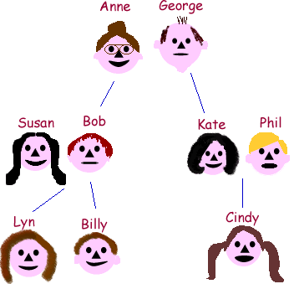
  1. | Anne is George's .
  2. | George is Anne's .
  3. | George is Kate's .
  4. | Anne is Bob's .
  5. | Kate is Anne's .
  6. | Bob is George's .
  7. | Bob is Kate's .
  8. | Kate is Bob's .
  9. | Kate is Billy's .
  10. | Bob is Cindy's .
  11. | Cindy is Bob's .
  12. | Billy is Kate's .
  13. | Anne is Billy's .
  14. | George is Cindy's .
  15. | Lyn is George's .
  16. | Billy is Anne's .
  17. | George is Susan's .
  18. | Anne is Phil's .
  19. | Susan is Anne's .
  20. | Phil is George's .
  21. | Bob is Phil's .
  22. | Susan is Kate's .

