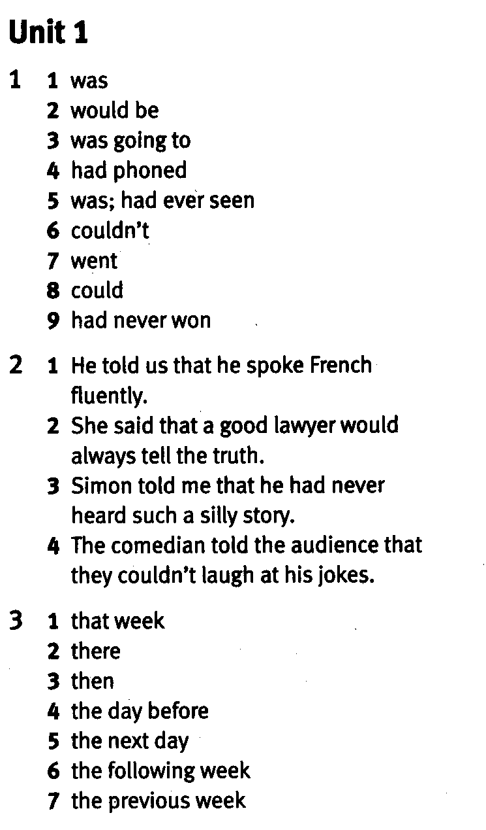

4
1 they had seen; the day before / the previous day
2 their; would win; the following
3 she had; been there
4 he was, that
5 she could; me / us; the next / the following
6 I should / we should
7 he had; the previous week / the week before

5
1 The doctor told me to stay in bed for a few days.
2 We asked the examiner to give us more time.
3 She advised him not to talk about politics.
4 The headmaster ordered the students not to run in the corridor.
5 My teacher advised me to watch DVDs in English.
6 The people next door asked us not to make so much noise.

6
1 My brother told me not to touch his CDs~
2 The teacher advised us to check our work.
3 My friend asked me to help her with her work.
4 I told my friend to phone me after ten o’clock.
5 He advised the children not to go near the dogs. .

7 Sample answers:
1 My mother advised me to talk to my teacher.
2 Our teacher advised us to go home.
3 I told her to wait a moment
4 The policeman asked us not to tell anyone.
5 Mary asked me not to laugh at her.

8 Sample answers:
1 did you arrive
2 can I find this information
3 it going to rain
4 is correcting the exam
5 you ever eaten Korean food

9
1 Suzy: 'Are you friends with Mary?'
2 Harry: 'What time does the programme start?'
3 Policeman: 'Where are you from?'
4 John: 'How much did you pay them?'
5 Teacher: 'Have you finished your work, Mike?'
6 Tina: 'Gary, will you explain the joke to me?'
10
1 Martin if he always danced like that
2 where she had bought her T-shirt
3 if Alex would lend him 20 €
4 Sarah where she / they had gone on Saturday night
5 why Anna was going out
6 if Carol could teach him to play the guitar

11 Sample answer:
... why he had to go to school. His mother replied that he had to go to school every day. Her son said that he didn't want to go to school. His mother asked him to give her two reasons why he shouldn't go to school. He told her that the students hated him and that he was very unpopular with the teachers. His mother replied that they weren't good reasons not to go to school and that he should hurry up and get dressed. Her son asked his mother to give him two good reasons why he should go to school and his mother replied that for one thing he was 1 52 years old, and for another, he was the headmaster!

12 Sample answer:
Doctor: 'You're very ill.'
Patient: 'Can I have a second opinion?'
Doctor: 'Yes. You're very ugly, too!'
1

