INSTRUCTIONS FOR USING GALI ONLINE (ENGLISH)

Dear Family,
This information is regarding the program GALI, learning the Catalan language.

First, you need to access to the following address:
http://clic.xtec.cat/db/act_es.jsp?id=3568

You'll see that there are different activities and thematic blocks, each with 2 different levels:
"Iniciació" (pear start) and "aprofundiment" (when you know more).

It is important to follow the order of the activities as they are proposed.

To access activities select "verlo (applet)"

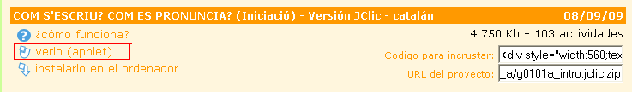

Surely will appear a request “firma digital”, select “Ejecutar”

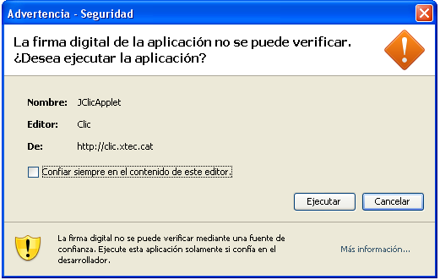

Once you are running the program, to skip the introduction, or pass forward, or go back, to an activity you have to use the arrows located at the bottom left side of the screen.

