AIN’T NO MOUNTAIN HIGH ENOUGH
(Words and Music by
Nickolas Ashford and Valerie Simpson,
Recorded by Marvin Gave and Tammy Tarrell)


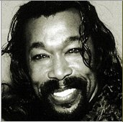
Listen Baby...
.Ain't no mountain high
Ain't no valley low
Ain't no river wide enough baby
If you need me call me
No matter where you are
No matter how far (don't worry baby)
Just call my name
I'll be there in a hurry
You don't have to worry
'Cause baby there
Ain't no mountain high enough
Ain't no valley low enough
Ain't no river wide enough
To keep me from getting to you, baby
Remember the day
I set you free
I told you, you could always
count on me, girl
Marvin Gaye
and
Tammy Terrell
Nickolas Ashford
and
Valerie Simpson
From that day on
I made a vow
I'll be there when you want me
some way, some how
'Cause baby there
Ain't no mountain high enough
Ain't no valley low enough
Ain't no river wide enough
To keep me from getting to you, baby
Noi
Noia
Tots

