YOU’VE GOT A FRIEND
(Words and Music by Carole King,
Recorded by James Taylor)

When you're down and troubled
and you need a helping hand
and nothing, oh, nothing is going right.
Close your eyes and think of me
and soon I will be there
to brighten up even your darkest nights.

You just call out my name,
and you know wherever I am
I'll come running to see you again.
Winter, spring, summer, or fall,
all you got to do is call
and I'll be there, yeah, yeah,
you've got a friend
you've got a friend.

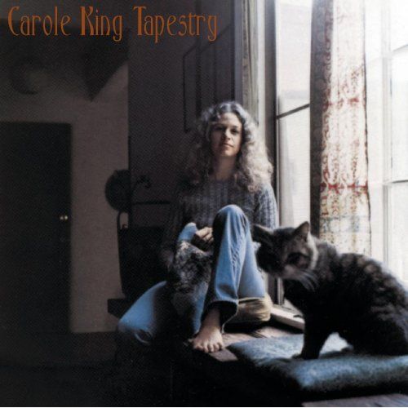
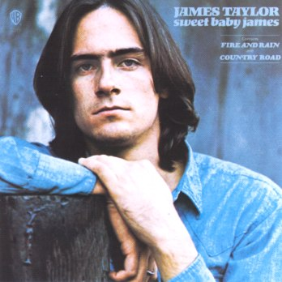

Carol King
(Nueva York, 1942)

James Taylor
(Belmont, Massachusetts., 1942)

