Name: Date:


READ: You are the captain of the USS Copernicus. Your job is to safely take your new crew on a voyage through the Solar System. Before you can leave you must prepare yourself by gathering as much information as possible about the Solar System. Here is a list of questions to help you prepare for your voyage.
HINTS:  Visit http://www.kidsastronomy.com/solar_system.htm to find the answers

 VOCABULARY
leave: partir de un lugar, salir, irse
gather: recoger, recopilar
voyage: viaje
crew: tripulación
strongest gravity: mayor gravedad
moon: luna
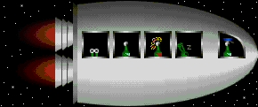
.

- If you leave the Earth travelling towards the Sun which planet will you come to first?

.
- Which planet has the strongest gravity?

.
- Which planet does not have rings?

.
- Which of the following planets has no moons?

.
.
.
.
.
.

