Task: Study visit and distribution of baguettes

Teacher Isabel reported to their pupils a situation that had occurred in the previous school year.
Teacher Elizabeth’s pupils made a field visit. When they arrived, the class was divided into four groups and each one was accompanied by an adult.


- 5 pupils went to observe the plants;
- 4 pupils went to observe the rocks;
- 5 pupils went to observe the animals;
- 8 pupils went to observe the fountains.

At lunch time, the school's assistant distributed the baguettes for four bags as follows:

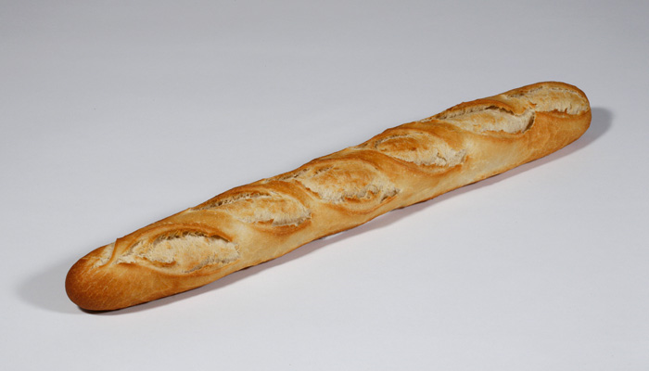
- 3 baguettes for the pupils who observed the plants;
- 3 baguettes for the pupils who observed the rocks;
- 4 baguettes for the pupils who observed the animals;
- 7 baguettes for the pupils who observed the fountains.

In the following day, they talked about the field trip and some students complained that the distribution of the baguette hadn’t been fair because some had eaten more than others.

1. The reported event happened in a 6th grade class. Verify and justify whether the reported distribution was fair or not.

2. keeping the same distribution, suppose that the baguettes had been divided equally to each group.

- Which part did each pupil receive in their own group?

- What was the group where each pupil ate more? And least?

Round up:

Number of baguettes | Number of pupils per group | Representation
Number of baguettes | Number of pupils per group | Fraction | Decimal number
3 | 5 | $$\frac{3}{5}$$ | 0,6
3 | 4 | $$\frac{3}{4}$$ | 0,75
4 | 5 | $$\frac{4}{5}$$ | 0,8
7 | 8 | $$\frac{7}{8}$$ | 0,875

Group that observed the plants | Group that observed the rocks | Group that observed the animals | Group that observed the fountains
0,6 | 0,75 | 0,8 | 0,875

