Non-negative rational numbers
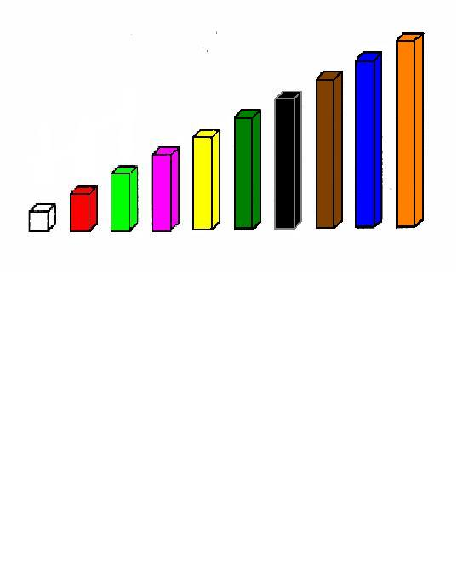
Compare bars
White
Red
Light green
Pink
Yellow
Dark green
Black
Brown
Blue
Orange

Task 1
Consider the dark green bar as to be the unit. What fraction of the dark green bar is represented by the light green one?
And the white bar? _______________________________________
And the red bar? _________________________________________

Task 2
Consider now the orange bar as to be the unit. What fraction of the orange bar is represented by the yellow one?
And the white bar? ________________________________________________
And the brown bar? ________________________________________________
Which is the bar that represents 0,9? ___________________________________
Which is the bar that represents 1 ? __________________________________
5
Task 3
Choose a bar with your group to represent the unit.
Can you get a bar that represents 1 of the bar that you have chosen? Which one is it?
2
____________________________________________________________________

Task 4
If the light green bar represents 3, which one represents the unit?
4
___________________________________________________________________

Task 5
If the red bar represents 1 , which one represents the unit? And which one represents
5
1 ?
2
_____________________________________________________________

