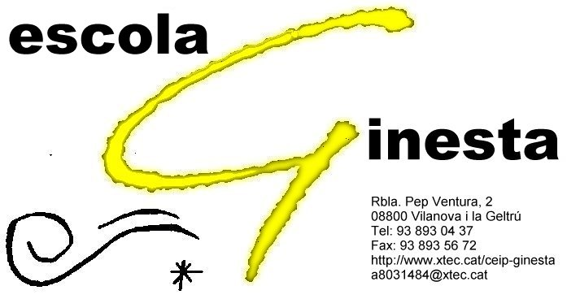

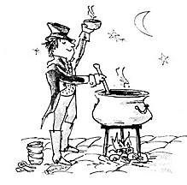

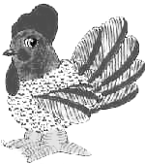

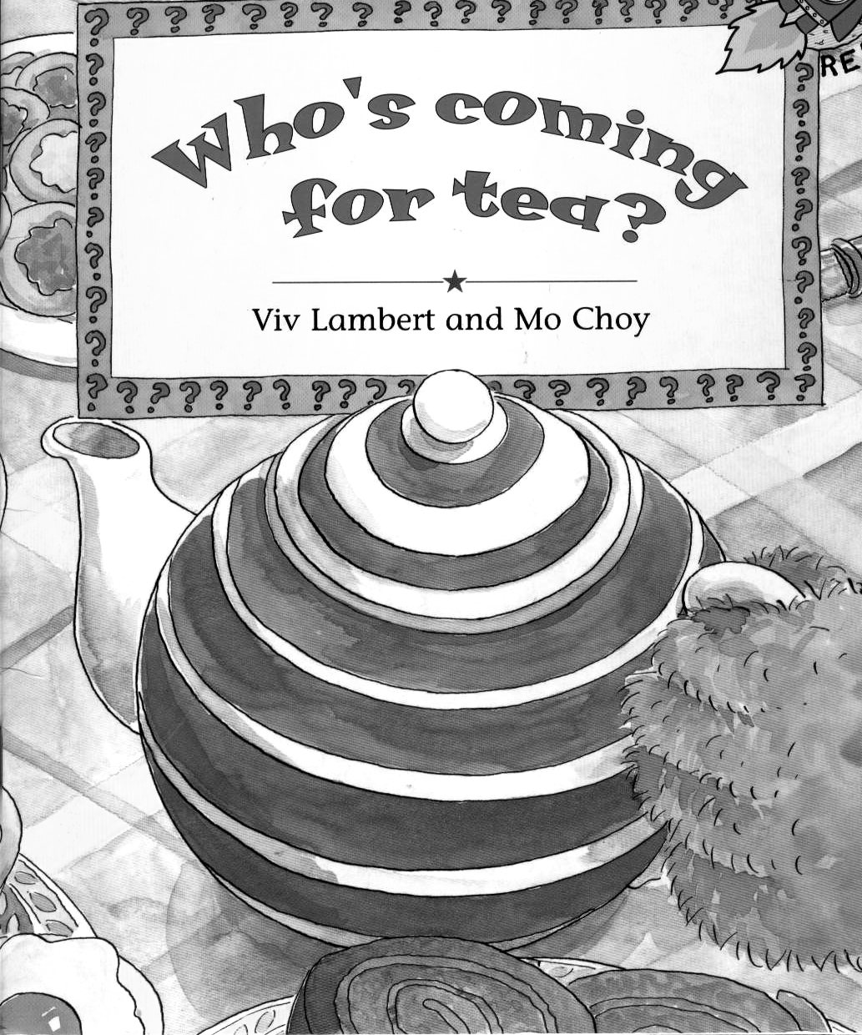

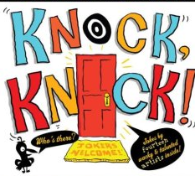

Cast
Stone Soup

Narrator: Rudy, Fernando
Tramp: Javi, Francesca
Woman 1: Nadia, Sande
Woman 2: Esther, Eila
Woman 3: Tania
Woman 4: Jessica
Man 1: Angel
Man 2: Santi, Ginés
Man 3: José Luis
Man 4: Cristian

Henny the Hen

Narrator: Erika, Cristian
Henny: Kristel, Andrea
Cat: Frank, Soraya
Dog: Kevin F, Alan
Rabbit: Anghelo
Horse: Adria, Toni
Pig: John, Paula
Lion: Alex, Nadia
Hippo: Marc, Marcos
Elephant: Estefania, Jandy

Who’s Coming for Tea

Alumnes de 6è B

Knock Knock, Who’s There?

Alumnes de 6è A


Theater Plays
16/06/2010
- Henny the Hen
- Stone Soup

Films

- Who’s Coming for Tea
- Knock Knock Who’s There?

Hi haurà representacions teatrals durant el matí per als diferents cicles.

A les 12:00 sessió per a pares i mares al gimnàs.
Us hi esperem!

