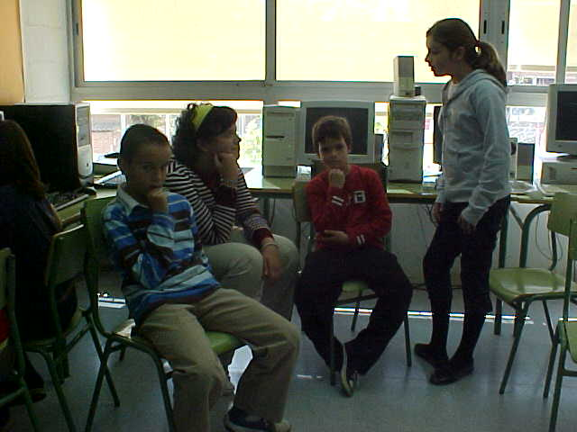
THE JOKE Alumnes de 5è: Ylenia group
I don’t know…
mmm…
i don’t know.

D
dddddddjckdjfhgh
mmm…
If it is is???

What is the Gardener’s pain?

The answer is:
that her daughter’s name was Daisy and She doesn’t like flowers

