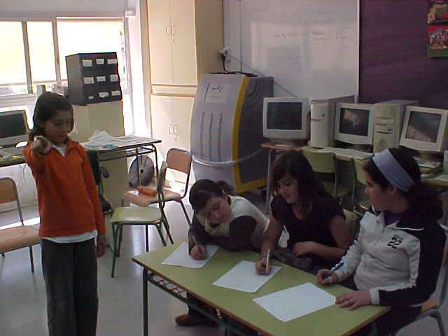
It's very
easy
Simona
It's copying!!!
Let's see........
And
3x2=6

0

00

0

0
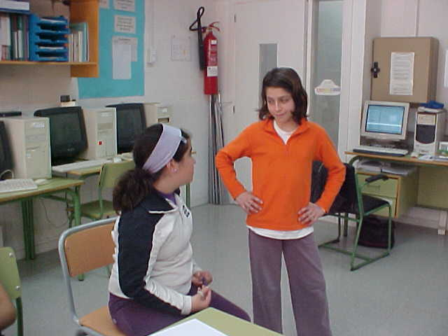
Teacher simona's
copying

Dont worry. I'll talk to her

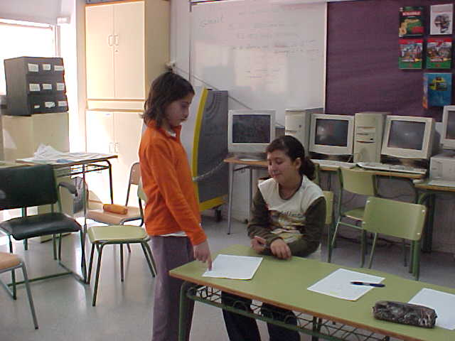
Have you copied?
You have lost a good chance
Yes, sorry

