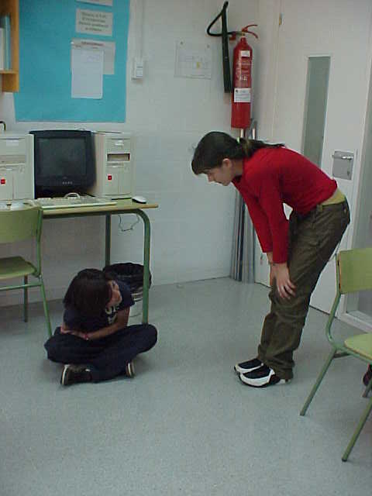
Núria Prunera i Carolina Rebolledo
What’s the matter with you?
Do you want to go to the toilet?
Well, It’s not necessary yet!
Um! I understand!
Jajaja!

