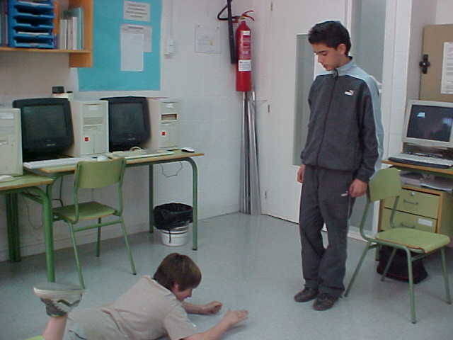
Joan Muñoz i Guillem Requeno
No, I was thinking in a good joke!
Are you praying?

