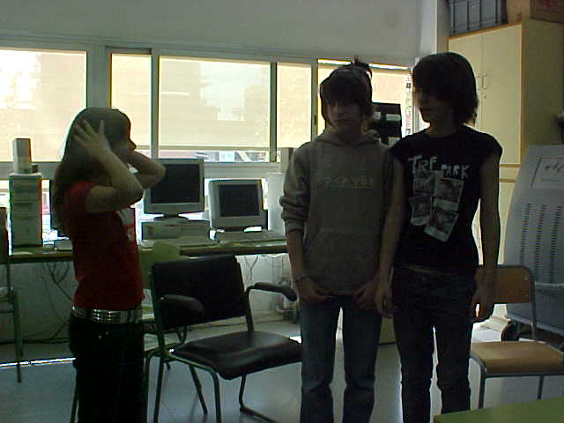
Oh no !!
I see double !
Hihihihi!
Uff...! You’re twins
It’s a joke!
It’s a joke!

Ona Rahn, Laia Mañosa i Aïda Rahn

