
The Monster
From “Banyoles”

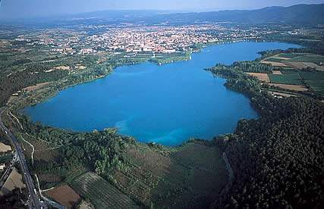
In the VIIIth century a monster lived in Banyoles,a village near Girona. The monster was a dragon, a terrible dragon! It appared in the village. It ate all the people. The dragon liked eating young people, and babies.
The people from Banyoles were very worried, and decided to give food to the dragon every day. But... oh! The food was a baby!
Every day a baby was given to the dragon for dinner.

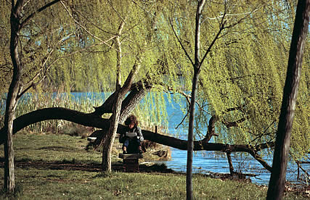
The days passed, and Banyoles was more empty every day.
One day, Carlemany troops arrived at the village.
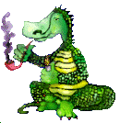
The troops tried to throw away the dragon. But... they were scared! The dragon burnt the horses and the troops. The army scaped from the village!
Two days later one soldier arrived in the village. His name was “Mer” and he talked to the dragon.
The dragon was calm, and Mer went to the village with the dragon. People were very happy and angry at the same time. One person said: -Kill the dragon!
But... the people had other idea. They wanted the dragon to become vegetarian.
It’s impressive but... they got it!

--->This legend has a song.

The Monster from Banyoles

-Ens ho diu la història d’un vell poble
que hi habitava un monstre fa molts anys
deia que treia foc per els orelles
per la boca, pel nas i pels queixals.

Es el mon-mon, monstre de Banyoles
que me-me-men menjava persones, oi tant.
Es el mon-mon, monstre de Banyoles,
una per dia sense fer terravestall.

-Com veureu, tenia tanta gana,
que s’empassava els bous de 3 en 3,
i als cavallers que amb ell volien brega
se’ls empassava com qui no menja res.

Es el mon-mon, monstre de Banyoles...

-I la gent, de tota la contrada,
un pacte amb gràcia amb ell varen signar,
donar-li cols, patates i alberginies
perque aquell monstre es tornès vegetarià.

Es el mon-mon, monstre de Banyoles...

