SONGS AND GAMES
Main page | Image | URL | Level / age | Topic / theme | Description | Useful for
PBS Kids |  | http://pbskids.org/dragontales/shareasong/zw/index.html | CI  CM | SONGS | Children choose one song and they complete first the lyrics with the use of pictures. | Interesting to learn vocabulary, and learn the song in a funny way.
 |  | http://www.bbc.co.uk/cbeebies/tweenies/songtime/songs/watchnsing.shtml
Hop along hopscotch |  | http://www.bbc.co.uk/cbeebies/tikkabilla/games/hopalong.shtml | CI | Numbers  Games | The Hop-along Hopscotch game encourages children's balance, number-matching and memory. The print-out kit to use away from the computer develops their physical skills. | Practise numbers. Learn some traditional english games. Probably they have played these games I catalan too.
Make a Dance |  | http://www.bbc.co.uk/cbeebies/boogiebeebies/make/ | CI | Dances | Children choose a dance, a dancer and the movements, so that they create the dance. | Great, children will enjoy it. It’s very funny
What am I? |  | http://www.bbc.co.uk/cbeebies/boogiebeebies/play/whatami/ | CI | Game | Children need to solve some riddles with pictures. | They answer the question “What am I?” they look at the guy moving and the real pictures are the options.
Do eggs grow on trees? | 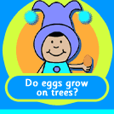 | http://www.bbc.co.uk/cbeebies/boogiebeebies/play/whatami/ | CI | Food | The pupils have to answer the questions about where do apples, eggs or milk grow. They play some activities.
 | 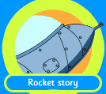 | http://www.bbc.co.uk/wales/bobinogs/games/game.shtml?9 | CI | Rockets | The children are asked to help the characters to mend their rocket to go back to their planet.
Big cook little cook |  | http://www.bbc.co.uk/cbeebies/bigcooklittlecook/ | CS | Cook  Food | There are many activities related to this topic: prepare a menu, healthy food, recipes… | It’s very interesting. Children can prepare a recipe. It would be nice to create a new recipe, and a nice activity would be for them to record the recipe with a camera and then show it to the others in the classroom.
Tikkabilla |  | http://www.bbc.co.uk/cbeebies/tikkabilla/stories/ | CM | Stories | This page is useful to encourage children to read. | The “through the window” activity is great. Children can see short videos including realia. They will enjoy them. See the next URL link.
Look trough the window |  | http://www.bbc.co.uk/cbeebies/tikkabilla/window/ | CM |  | Through the Window helps children to understand the world around them and explore different experiences and cultures.
Cbbc WILD |  | http://www.bbc.co.uk/cbbc/wild/ | ALL | Animals | Lots of information,games, activities related to animals.
ARCTIC ICE |  | http://www.bbc.co.uk/cbbc/wild/arctic/games/iceage/arcticice.shtml | ANY | ARCTIC animals |  | Just a lot of fun in the Arctic.
SKID | 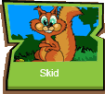 | http://www.bbc.co.uk/cbbc/wild/games/flash_skid/flash_squirrel_scramble.shtml | ANY | Squirrels | Help Skid the squirrel to find his 3 piles of accorns. Be careful, the forest is dangerous. | Funny game. Just have fun with it.
WILD |  | http://www.bbc.co.uk/cbbc/wild/games/ |  | Animals | The 2 previous games are on this page. You can find some more in it. | Different games. Interesting all of them.
MUSIC AND SONGS |  | http://www.bbc.co.uk/cbeebies/drilldown/music/2/1/1/ | ANY | SONGS | There are many songs, from nursery, traditional to new modern songs. You need lots of time to listen to them all. | I enjoyed specially the auttumn harvest song.
BBC  ALL MUSIC AND SONGS |  | http://www.bbc.co.uk/cbeebies/firemansam/music/firemansamkaraoke.shtml | CI | SONGS firemen | It’s incredible, you listen to the song (the lyrics are shown) , you watch a video, and you can play music with 4 different instruments. | Again, it’s fantastic.
LITTLE KIDS SONGS |  | http://www.britishcouncil.org/kids-songs-alphabet.htm | CM | THE Alphabet | A song to learn the alphabet. | There are also games to practise the alphabet: how far can you say it?
LITTLE KIDS SONGS | 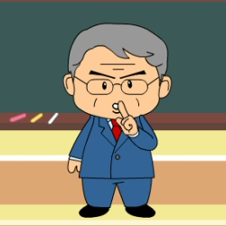 | http://www.britishcouncil.org/kids-songs-quiet-please.htm | C M | Children quiet please | A song about school. | I’ll use it tomorrow, in 3r.
MAKE A MONSTER | 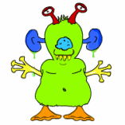 | http://www.britishcouncil.org/kids-games-make-a-monster.htm | CM | The body | You create a monster and after that you listen to it singing, shouting, sneezing… | There are some more possibilities to learn on the body topic.
SONGS  Help your little brother | http://www.britishcouncil.org/kids-songs-traditional.htm |  | CI | SONGS | Different songs for younger children.
PLANET PURSUIT GAME |  | http://funschool.kaboose.com/globe-rider/space/games/game_planet_pursuit.html | CM
 |  | http://www.scholastic.com/magicschoolbus/home_2.htm
THE MAGIC SCHOOL BUS |  | http://www.scholastic.com/magicschoolbus/home_2.htm
THE HANGMAN |  | http://www.englishclub.com/esl-games/hangman.htm | CI  CM  CS | Differents topics | No need to describe this game. | It can be useful at any age, at any moment, if you choose the right topic to your studetns they’ll be delightful.
PBS KIDS SONGS |  | http://pbskids.org/buster/songs/index.html | CM  CS | Songs | There are lots of songs, you choose one of them and then listen to it and read the lyrics. | They can be useful at any moment. They have rhythm and it’s good music.
THE MUSIC BOX | 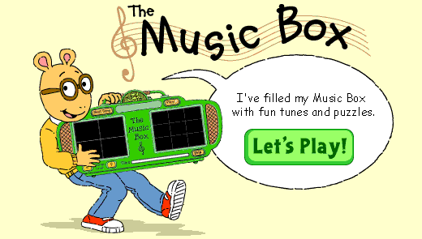 | http://pbskids.org/arthur/games/musicbox/index.html | CM  CS | SONGS | The children are asked to arrange a puzzle as they listen to a song. | It’s a nice game, but I didn’t pay attention to he song as I was arranging the puzzle so, will children do it? Anyway, it’s a very funny activity.
PARENTS |  | http://www.pbs.org/parents/birthdays | parents | Birthdays’ parties | How to prepare a party depending on the topic you choose. | It’s great, I know where I will take the information from the next time I have to prepare a party for my children (I’ve got three, 7,7 & 4)
PBS TEACHERS |  | http://www.pbs.org/teachers/earlychildhood/pbskidsintheclassroom/index.html | teachers | Planets
SCHOLASTIC |  | http://www.scholastic.com/magicschoolbus/games | CS | Planets | Play with the magic school bus. The teacher is hidden in different planets. Where’s she? | You can also have a guided tour by the space.  An interesting web page.
EXPLORATORIUM |  | http://www.exploratorium.edu/ronh/weight/ | CS | Planets | Children are asked to introduce their weight on Earth and then they can discover their weight on other planets or stars. | It’s very interesting for children realize that their age is relative, that they would have a different age or a different weight on other planets.
ENCHANTED LEARNING |  | http://www.enchantedlearning.com/subjects/astronomy/ | CS | Planets | Children are asked to introduce their age on Earth and then they can discover their age on other planets or stars.
APPLES 4 THE TEACHER |  | http://www.apples4theteacher.com/memory.html | CS | Planets | Memory game. | Learn the names of different objects related to the space.

