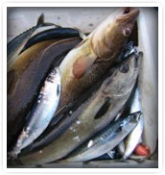
Fishery

Greece is a country with a large tradition in quality fishery.
In testimonies found in manuscripts dating from the fifth century, it has been proved that the Greeks were enjoying fishery and included them in their quality dishes. In Homer’s texts fishery is mentioned as quality food, while Plutarch cites pieces of advice for the fishermen in his own texts.

Today, the vast variety of Greek fishery and their premium quality reinforces their global recognition. Fishery fans around the globe include Greek Fishery within their choices and honor them with their preference. Although modern technology has changed fishing industry worldwide, the majority of Greek coastal fishermen still fish with the traditional methods, using their five to six metre boats, which constitute 90% of the total fleet.

The Greek sea fishery landsaround 130,000-160,000 tonnes of fish and seafood every year. About 90% of this total are caught in the Aegean Sea.
The most important species are :
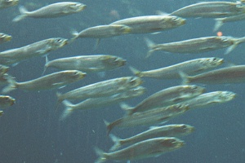
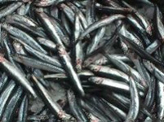
Sardine anchovy

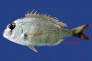
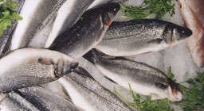
javascript:void(0)seabream seabass

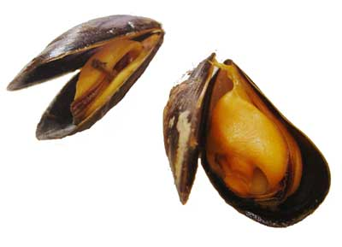

Mediterranean mussels.

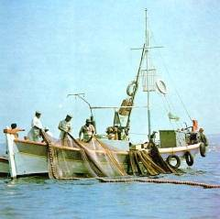
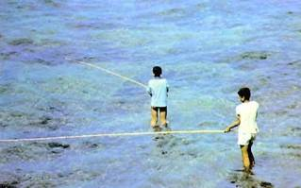

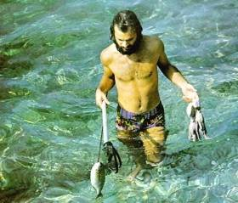
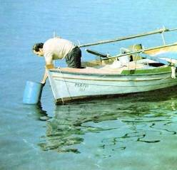

Greek Food: Fish and Seafood

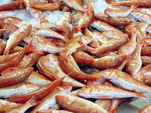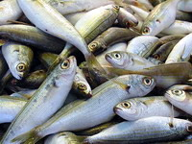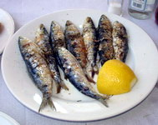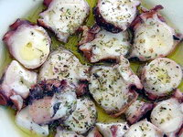
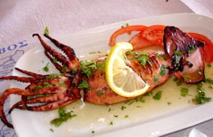
If you take a look at a map of Greece you will see why fish is such an important part of the Greek diet. For such a small country there is a lot of coastline, which is why they have such a strong history of seafaring. Eating seafood goes along with that. Unfortunately, the sea which was once so abundant is now barren in places through over-fishing and the Aegean sea simply can't keep up with the demand of a seafood-loving population whose numbers swell during the tourist season. Fish can be very expensive, though there are inexpensive fish available year-round, and these are just as tasty as the expensive ones.
Let’s start at the bottom and make our way up the fish chain. The cheapest fish are sardeles (sardines), gavros (anchovies), kolios (mackerel), gopa (bogue) and marides (smelt). Also in this inexpensive category are kalamari (squid), though the frozen variety is usually, if not always, imported from California, China and other far away places. When kalamari is in season, they will tell you on the menu that it is fresh. When cut and fried it is usually frozen but fresh kalamari is grilled or fried whole. In the kalamari family is also thrapsala, which to you and I looks like a squid and tastes like a squid but is not a squid. Well, maybe it is a squid, but they call it thrapsala and like fresh kalamari they serve it grilled or fried whole. In the same family are soupia (cuttlefish), which have shorter tentacles and are never fried but cooked in a stew with tomato sauce. Octopus, which is eaten in small amounts as a meze (snack) can be local or can come from China or the Atlantic. Octopus can be served in a number of ways which I will go into later. In between there are a number of fish whose price depends on supply and include xifia (sword fish), a couple varieties of Mediterranean tuna, and a whole family of bream, trout and even mollusks. Included among them is fagri (red porgy), sargos (sea-bream), lavraki (sea bass), lithrini (pandora), and synagrida (dentex) most of which are either baked or grilled and sold by the kilo.
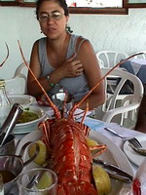
Then at the top of the fish food chain is astakos (lobster), which can cost a small fortune and is familiar to anyone who has taken a charter sailboat around the islands, because many skippers take their clients to the tavernas that serve fresh lobster or the newly popular astako-makaronada (spaghetti with lobster). Not surprising, since skippers often get a commission from the restaurants for any business they bring and a table full of lobster can cost a few hundred euros or more. But here's a tip. Save your lobster-money for home. Mediterranean lobsters are over-rated, under-tasty and few chefs have mastered the cooking of these creatures. They also lack claws which besides the tails are the only edible part, unless you want to spend the night sucking bits of meat from legs and antennae. Yes. The Greek lobsters have meat in the antennae. But not enough to justify eating them. In Milos a tourist saw lobsters with claws at the restaurant of the famous Roberto at Da Peppe. "Where did you find lobsters with claws?", he asked him in wonder. "On the airplane" he said in his broken English. They were flown in, maybe from Maine, definitely from somewhere on the Atlantic.
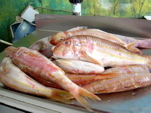
So, while you are allowing the lobsters of Greece to re-establish themselves and maybe grow some claws, what can someone who wants to spend a lot of money on fish buy that is worth the expense? We have one word: Barbounia. The red-mullet is the best tasting fish you will ever eat, whether fried or grilled. Is it worth 55 euros a kilo? Well, luckily you can't eat a kilo. Half a kilo is enough for two and though you may want more after the last morsel of fish, skin or even bone is eaten, chances are there will be other fish on the table too. For those who think 55 euros is a little steep, there are koutsomoures, the paler cousins of the barbouni, which some people like better and are cheaper.
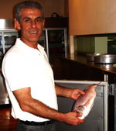
Going out for a fish dinner is always a fun time if you are with someone who knows what they are doing. Usually the fish restaurants are on the sea, outside of Athens. One of my favorite areas is Anavissos, on the way to Sounion, a small seaside town famous for its fish tavernas. There are waiters standing in the road beckoning for you to park your car by their dining area, so they can impress you with their fresh fish, keeping in mind that if the sea has been rough for several days there may not be any fresh fish. But once you sit down and look over the menu, the procedure is for the leader of your group (the guy who knows what he is doing) to follow the waiter to the kitchen where he is shown what fish is available. Usually a fagria, sargos, or tsipoura, all in the bream family and delicious grilled, cost more than we normally like to spend on several dinners.

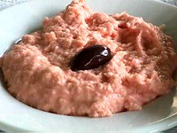
While the big fish is cooking, we will have ordered some mezedes to go along with it. Among them is tarama salata (fish-row salad –photo) usually made from the eggs of carp, but if you are lucky, from kefalo (gray mullet) which is what it was originally made from before the people who were eating it began to outnumber the fish who were laying the eggs. You have to ask if the restaurant makes it or if it comes from a container. Not that it matters. You can season the tarama from the supermarket, so that it tastes pretty good. A plate of fried gavros (anchovies) is as essential as a plate of fried potatoes and are eaten the same way, with lemon or vinegar squeezed on them. Lemon makes them soggy. Vinegar keeps them crispy. Both taste great. These fish are about the size of your small finger and cooked almost whole. Their heads are cut off because they give it a bitter taste. Marides (smelt) are the same size but the heads are left on. You eat the whole thing. Don't bother trying to pick out the bones or you will be there all night. Papalina are very small sardines, another great starter. Even smaller are the atherina, which are to fish as onion rings are to potatoes. Maybe that's a bad analogy. (Or a ridiculous one.) So let’s explain. In Kea, at the famous Rolando's restaurant in Hora, he mixes atherinia with flour and sliced onions and then deep-fries the whole mass and serves it with vinegar and you sort of pull it apart and eat it. Like onion rings sort of.

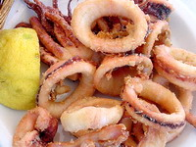
Fried kalamarakia (squid) are also listed in the mezedes-appetisers section of the menu in most restaurants since they are trying to discourage you from making a whole meal out of it, since it is so cheap. Don't let that stop you. When there is fresh kalamari available the menu will tell you. In fact by law the menus have to let you know whether a fish is fresh or frozen. If you see (kat) in parenthesis next to the fish you are ordering, that means it is frozen. Kalamari and thrapsala are both delicious grilled or fried and can also be stuffed. But there is nothing like a whole fresh kalamari fried to perfection at Paradosiako Cafeneion in Athens. Thalia, the owner-chef of a small ouzerie in the port of Vourkari, Kea, makes these tiny baby kalamarakia that are just amazing.

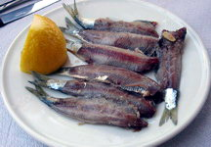
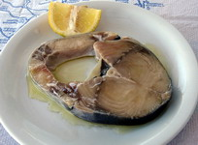
Sardeles (sardines) are eaten in several ways, either as mezedes (appetisers) or main courses. Most people like them grilled. Fried is great too. They can also be served baked in tomato sauce with lemon and oregano, but this is less common. The smaller the sardines the better they are. In Lesvos, during the month of July, when the sardines are a certain size, they are eaten as sardeles pastes (photo). The fishermen go out, catch a net full of sardines in one of the two big bays, and cover them in salt. That night they are ready to eat, raw, like sushi. They go very well with ouzo, in fact they are the best thing to eat with ouzo. You can find them later in the summer too, but as the sardines grow, they need to be in salt longer. Eating them requires a little technique, but it can be mastered quite easily. You hold the tail of the sardine with two fingers on one half and two fingers (of the other hand) holding the other half. Then you gently pull and the fillet (but tiny) separates from the backbone. Then you take your fork and run the remaining fillet and tail through the tines (that's a real word; its the things that make a fork a fork) and separate the other filet from the backbone. Then you eat it or, if you don't like it, give it to the cats that have been watching you with interest. Some restaurants serve sardeles pastes plain and others with oil, lemon or even vinegar.

Another meze (appetiser) is lakerda, which is in the tuna family. The fish is made into steaks about half an inch thick and marinated in lemon and olive oil for a few days before being served. This also goes well with ouzo and is a popular dish on Lesvos, where perhaps the best lakerda is found at a little hole in the wall restaurant in Campo Antissa, known as Kostas. Gavros marinatos (marinated anchovies) are a less intense, less salty, fresher version than the anchovies you get on your pizza, usually served with oil and vinegar. This is also served widely in Lesvos but can also be found in many ouzeries in Athens and around the other Greek islands. One of the best varieties is made by Melinda at the Captain's Table in Molyvos: fishes are topped with oil, lemon, garlic and parsley.
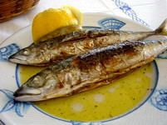
The interesting thing about Greek fish is that the cheapest ones are the best for you. Gavros, sardeles, and kolios (mackerel) are the highest in omega fatty acids and of the three kolios is the tastiest and most filling. It is usually served grilled though it can also be fried. The best kollios is made in Lesvos and is called gouna. The fish is opened and dried in the sun with herbs. Then it is grilled. You won't taste anything better, especially if you go to the small town of Pirgi Thermi and eat at one of the small fish tavernas right on the water. You can also taste it in Naoussa of Paros and in Skala of Eressos, in Lesvos.
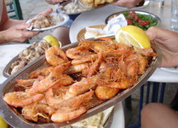
Garides (shrimp) are very common and they are fried whole and eaten whole, even the heads. Garides saganaki is a meze of baked cheese, tomato sauce and shrimp, which is found in just about every ouzerie and mezedopolion, which are restaurants specialized in ouzo and snacks, like tapas. Karavides are giant salt-water crayfish, very expensive and very un-satisfying. In Volos there are a number of dishes with crabs and other shellfish, that are eaten as mezedes. There is even a crab that is a very close cousin of the dungeness crab from California. In Lesvos there is something called agrio-garides, which are a cross between a shrimp and a lobster tail and are deep fried and eaten whole.

A very popular dish is psarosoupa (fish soup), which is served at many working-class tavernas as well as the restaurants in the Plaka of Athens. The most commonly used fish is the rofos (grouper), a giant rock-dwelling fish that has to be caught one at a time and usually with a struggle. A rofos can be half the size of a man and its meat can be grilled in steaks too, but more commonly it is used in psarosoupa, along with some of the other rock fish and scorpios (scorpion fish). When you order psarosoupa, they ask you if you want it with the fish. If you get it with the fish, it comes in a bowl with the broth and some potatoes, carrots, onions, and a plate with the fish. It is usually in an avgolemono (egg-lemon) broth. This is one of the healthiest and best tasting dishes in Greece. The soup at Byzantino in Plaka is excellent. In some island fish restaurants you can specially order a whole pot by calling the day before or in the morning.

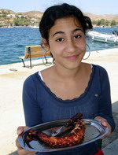
Octopus is the most misunderstood creature in the sea. Very intelligent, the Greeks have been struggling to outsmart them for centuries and now the few that remain seem to be the smartest and hardest to catch. No problem. There are plenty in China and chances are the octopus you eat in Greece will not be Greek. Still you have to feel a little bit sad for the slaughter of an animal that has the intelligence of a house-cat and none of the bad habits. A well cooked, expertly seasoned octopus can taste like filet mignon. The best way to eat it is grilled. Marinated is good too. The last choice is with macaroni or in stifado with baby onions in tomato sauce. But you have to know how to cook an octopus, because if you don't, it will take you half an hour to eat one bite. It can be very tough if not made correctly and part of the procedure is the endless beating of it on a rock. In some places they say the fishermen put them in a washing machine (without soap) until they are tender. Octopus goes best by the sea with a glass of ouzo, or even a bottle.
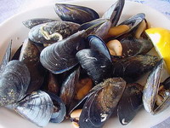
Mydia (mussels) have always been eaten in certain areas of Greece, but now they are almost mainstream and can be found in many tavernas in the islands as well in Athens, either steamed or in saganaki. There are other clams too that have found their way on to the menus, many of them from farms. There are a number of popular fish that are now farmed including pestrofa (fresh-water trout), salmon, eel and carp. There is talk of farming turbot, bluefin tuna, yellowtail, and octopus too. The most popular farmed fish are Tsipoura (Gilthead Sea-Bream) and Lavraki (Mediterranean Sea Bass). If you drive along the coast, you will see some of these fish farms, even as close as Sounion near Athens.
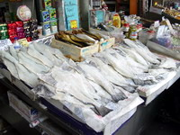
Bakaliaro (cod) is probably the most widely eaten fish, especially in the winter. If you go to the Athens Central Market or just about any island supermarket you will see salted dried cod. This can be served in a plaki, which is a sort of a roasted fish with vegetables in a tomato sauce and is usually made with fresh cod when it is available. But the most popular way to eat cod is in the basement taverns of the Plaka, which are only open in the winter and specialize in bakaliaro with skordalia ( batter-dipped deep fried cod with garlic sauce). As heavy as it may be, this is the best way to eat cod. The salted cod has to be soaked for a couple days, changing the water every so often. Similar is a dish called galeos, which is actually a small shark like what we call dog-fish, instead of 'red snapper' which is the translation many restaurants use to keep any tourists from thinking that there may be sharks in the happy seas of Greece. Galeos is also deep-fried and served with skordalia. If you don't like bones, then these two dishes are for you.
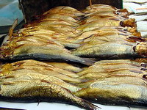
Anyone who has eaten in a sushi restaurant has encountered the delight called uni, which is sea urchin. It is the worst tasting sushi dish you can find, especially when compared to fresh sea-urchin. There is only one way to eat fresh sea urchin, called achinos, and that is to dive down and catch one, cut it, open and eat it right there. You can find it in some fish tavernas, notably on the island of Aegina, but as fresh as they claim it to be, there is nothing like eating it right out of the sea. The females are easily recognizable because they cover themselves with bits of sea weed, paper, or whatever they can find nearby. You have to pick them up carefully and bring them to the surface, take your knife and slice them open and eat the orange eggs. You won't believe how sweet they are. Don't eat too many.
In the Athens Central market and in smaller markets on the islands you can find rega, (smoked herring) which is served covered in olive oil and considered a winter food because it is so salty. You can find all sorts of canned sardines, some in olive oil, which you can just open and eat, and some that is caked in salt which takes some work to make edible. You can also find in cans or packaged in plastic containers kolios (mackerel), gavros (anchovies), lakerda (tuna) and even marinated octopus. Scoumbri, which is in the mackerel family, is sold whole and pickled and if you are a pickled fish fanatic, you will love it, but if not, you may want to let it go. It will stink up your room and may even alert the airport dogs to contraband.
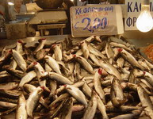
Also in the probably not-a-good-idea-to-eat category are the kefalo (gray mullet) which live in the harbors and eat the bread that the tourists toss to them. These fish tend to like polluted water, though they are everywhere. They are sold in some restaurants and in the Athens central market. When they are fresh and clean, their gills will be exposed and a bright red like in the photo. Another interesting fish that you may come across is the smyrna (moray eel) which are fairly common in the Greek sea, though you probably won't see them unless you are diving after sunset. They are big and nasty looking with the sharpest little teeth you have ever seen. They are quite edible, delicious fried, but such a pain to clean that few chefs will mess with them. You don't have to be afraid of them unless you are snorkeling and decide to tease one by sticking your hand in his hole.
One good fish which is also uncommon is the skaros, described by the ancient Greeks as the parrot fish, which is grilled whole, guts and all. In fact there is a little song the fishermen sing about the skaros:
The rofos you eat the head
melanouri the body
but for skaros eat the shit
and tell me which do you like better?
For a real treat visit the fish section of the Athens Central market on any weekday or Saturday morning. You will see just about every fish in Greece and many from outside Greece and even outside the Mediterranean. Make sure you are not wearing flip-flops or open sandals because the floor can be wet and nasty.
Remember too that when you go to a fish restaurant some of the fish will be sold by the merida (portion) and some by the kilo. Look at the price per kilo before you order, so you don't get surprised when you get the bill. The waiter will always recommend the most expensive fish. What are the best fish? In this order they are: fried barbounia, sardeles pastes, grilled kollios, grilled octopus, fried gavros, grilled sardines and bacaliaro me skordalia. The best places for fish? Just about anywhere on the islands. In Athens the fish-taverns at Anavissos are worth the trip, especially if you want to visit Sounion. If you are in the city, the small Paradosiako Cafeneion on Voulis street makes great fried and grilled fish, usually of the inexpensive variety. Violetta in Foikiinos Negri street is a nice little fish-taverna too. On the road to Kessariani there are a number of fish tavernas in Anageniseos Square. If you can get to Kea, Rolando, in Hora is recognized as a master in fried fish.

GREEK FOOD RECIPES

Sardines
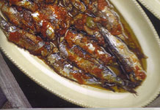
Info:
Cuisine: Greek
Course/Dish: Main Dish
Main Ingredients: Fish

Ingredients:
For Sardines with oregano
1 kilo sardines, with head and gust removed
1 coffee-cupful olive oil
2 teaspoonfuls oregano
juice of lemon
salt
For Sardines with tomato
1 kilo sardines, with head and guts removed
1 coffee cupful olive oil
1 coffee cupful parsley, finely chopped
400 gr tomatoes, finely chopped
Instructions:
Sardines have cast a spell on my cooking. They are not only tasty but also healthy. Their oil contains what we call “benign” cholesterol, which struggles against the other “malign” cholesterol.
One of the best ways of cooking them is grilled, and for the gourmet, wrap each individually in a vine leaf and then eat together. The vine leaf substitutes for lemon.
If you haven’t a grill or an organized barbeque, cook the sardines in the oven in two different ways. With a little oregano, oil and lemon and of course a pinch of salt or with finely chopped tomato, parsley and olive oil.

made by

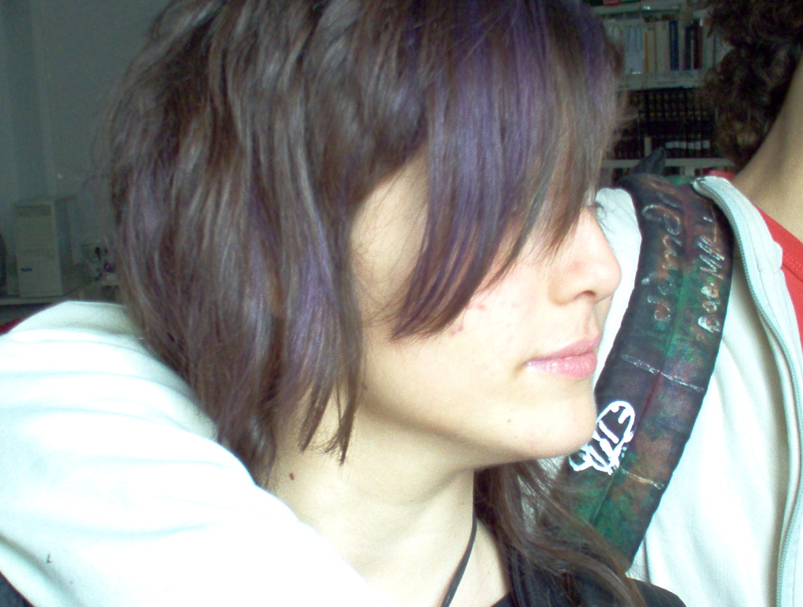 | 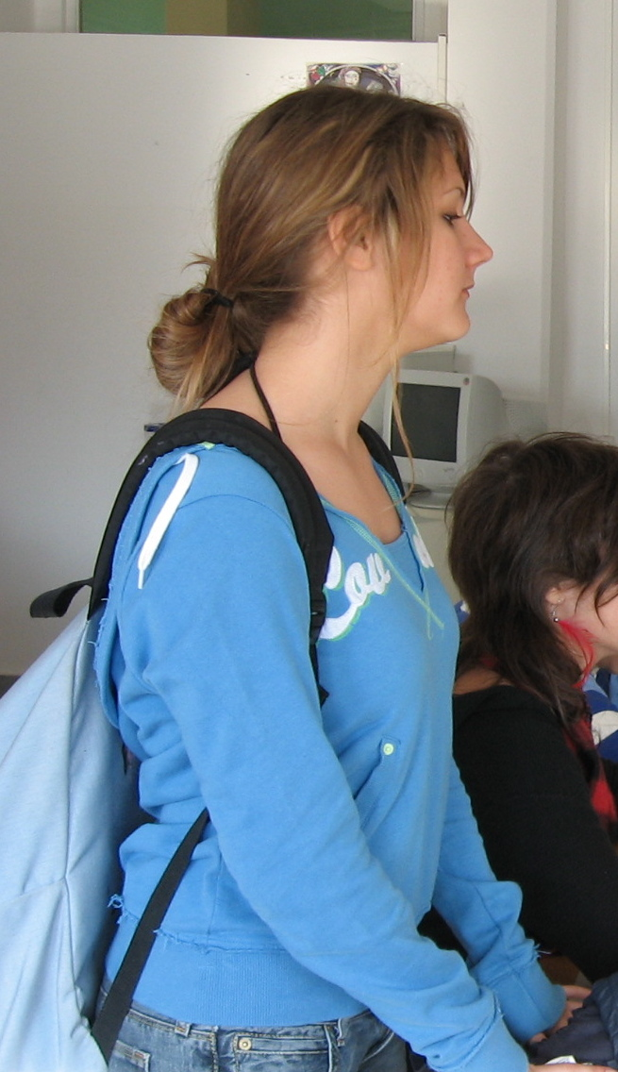
Athena Tryferopoulou | Victoria Rondiri

3rd class

2nd Gymnasium of Alimos, Spring 2007

