Mammals!!!
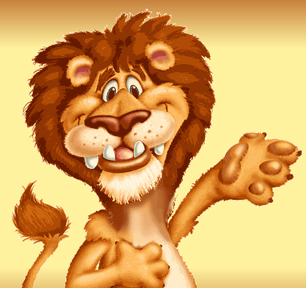One Class of animals is called mammals. Many people keep mammals as pets, but mammals can be farm animals, or even wild animals! Most mammals live on land.
What makes an animal a mammal? Well, four things, really. Mammals breathe with lungs. All mammals are warm-blooded animals, which mean that the temperature of their bodies stays just about the same all the time. Even if it gets very cold or very hot outside, a mammal's body temperature stays the same. If a mammal gets very hot, it looks for shade or water or sweats. If a mammal gets very cold, it can grow thick hair or a layer of fat to keep its body warm.
Mammals have skin and hair on their bodies. The hair protects the skin and also can keep the mammal cool or warm. The hair comes in many colours! Usually a mammal's hair helps it blend into its surroundings.
Mammal babies are born alive. The mother carries the baby or babies inside her body until it is time to be born. Then the mother feeds her babies milk until they are strong enough to find food on their own. Do you know what? You are a mammal!
Mammals Comprehension Sheet
A. Use the reading sheet to help you answer the questions:
- Where do most mammals live?
- What do mammals use to breathe with?
- What kind of blood do mammals have?
- Are mammals oviparous?
- How are mammals born?
- Write the four most important things you read about mammals.
- Are you a mammal?
B.What is the meaning of...
-pets -wild -hair -fat -skin -blend -born alive -feeds

