Map of the Zoo 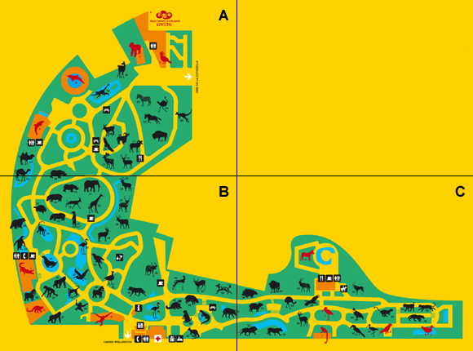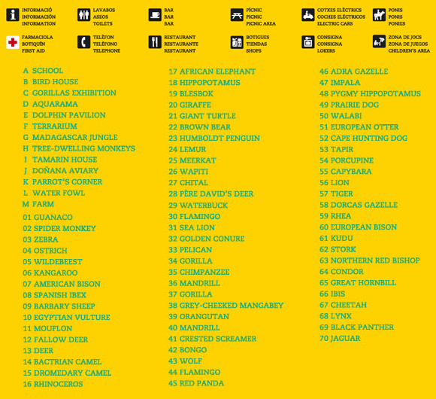

A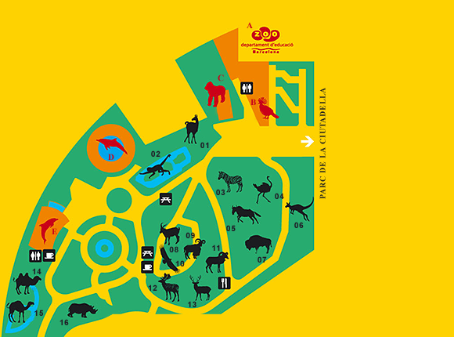B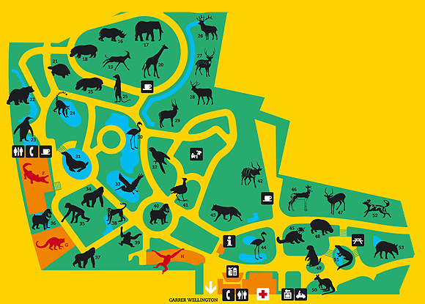
C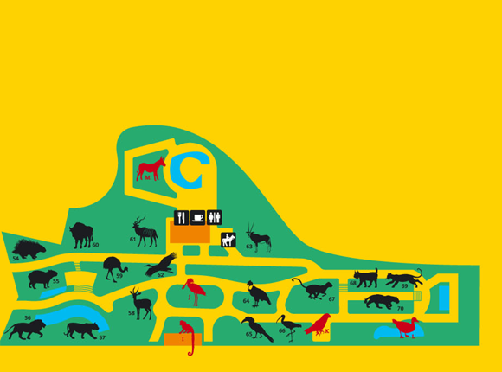
a. Who am I?

You need to look for the clues in the Zoo and you will discover who I am. If you want to gain extra points give the information in the blanks provided. You will find this information on the animal’s information plate, asking to zoo staff or just revising what you already know

Animal 1

I am one of the biggest animals in the world. I have a very long neck and very long legs which help me eat the highest leaves on the trees. My skin is yellow with brown spots. I live in the African savannah.

Who am I? ___________________________________________________________

Extra points.
Reproduction: ______________________________________________________
make a circle
Food: carnivorous-herbivorous – omnivorous → make a circle
Life Span: ____________________________________________________________
Gestation period: ____________________________________________________

Other comments:
__________________________________________________________________________________________________________________________________________________________________________________________________________________

Animal 2
I am the biggest bird in the world. I cannot fly but I run very fast. I eat seeds, grass, fruit, insects and small vertebrates. I often ingest stones to help me digest food. I live in the African savannahs.

Who am I? ___________________________________________________________

Extra points.
Reproduction: ________________________________________________________
Food: ________________________________________________________________
Life Span: ____________________________________________________________
Gestation period: ____________________________________________________

Other comments:
__________________________________________________________________________________________________________________________________________________________________________________________________________________

Animal 3

I am a primate. I have a red coloured face. I live in tropical rain forests in Congo, Cameroon and Gabon. I live in groups of 50 animals. I eat seeds, fruit, insects, snails and small vertebrates. I am an endangered species.

Who am I? ___________________________________________________________

Extra points.
Reproduction: ________________________________________________________
Food: ________________________________________________________________
Life Span: ____________________________________________________________
Gestation period: ____________________________________________________

Other comments:
__________________________________________________________________________________________________________________________________________________________________________________________________________________

Animal 4
I am a feline. I live in the savannah in Africa and Arabian Peninsula. I hunt other animals (antelopes, gazelles) to eat. I have a small head and spots on my skin I am the fastest sprinting animal. I can run up to 112Km per hour.

Who am I? ___________________________________________________________

Extra points.
Reproduction: ________________________________________________________
Food: ________________________________________________________________
Life Span: ____________________________________________________________
Gestation period: ____________________________________________________

Other comments:
__________________________________________________________________________________________________________________________________________________________________________________________________________________

B. Complete the list
1. Write 5 animals that hatch from eggs
__________________________________________________________________________________________________________________________________________________________________________________________________________________

2. Write 5 animals that eat meat (carnivorous)
__________________________________________________________________________________________________________________________________________________________________________________________________________________

3. Write 5 animals that live in Africa
__________________________________________________________________________________________________________________________________________________________________________________________________________________

4. Write 5 animals that are endangered.
__________________________________________________________________________________________________________________________________________________________________________________________________________________
Glossary:
Clues: things you use to discover learn or find something. PISTES
Gain: GUANYAR/OBTENIR
Blanks: ESPAIS EN BLANC
Animal’s information plate: PLAQUES D’INFORMACIÓ DELS ANIMALS
Staff: people working in a place. TREBALLADORS/MEMBRES
Neck: COLL
Leaves: FULLES DELS ARBRES.
Savannah: SABANA
Life Span: LONGEVITAT número d’anys que viu una persona o animal.
Gestation period: TEMPS DE GESTACIÓ
Other comments: ALTRES COMENTARIS
Grass: HERBA
Ingest: INGERIR/MENJAR
Primate: PRIMATS
Tropical rain forests: SELVES TROPICALS
Seeds: LLAVORS O GRA
Endangered species: ESPÈCIES EN PERILL D’EXTINCIÓ
Feline: FELÍ
Spots: PUNTS/MOTEJADA
Hunt: CAÇAR
Skin: PELL
Hatch: SORTIR/ NEIXER
Meat: CARN

