THE FOOD CHAIN!!!

Every living thing on Earth depends upon other living things in order to stay alive. Scientists have studied different habitats and found how animals and plants are linked in a "chain" of life.

The sun produces energy. The suns' light lets plants make their own food and grow. When plants grow, other animals eat the plants to get energy. A food chain is the transfer of energy from one living thing to another living thing.

Plants are called ______________ because they are able to use light energy from the Sun to produce food from carbon dioxide and water.
The food chain is made up of PREDATORS - the animals that hunt- and PREY - the animal that the PREDATOR hunts.
Animals cannot make their own food so they must eat plants and/or other animals. They are called _____________. There are three groups of consumers. Animals that eat ONLY PLANTS are called ________________ (or primary consumers). 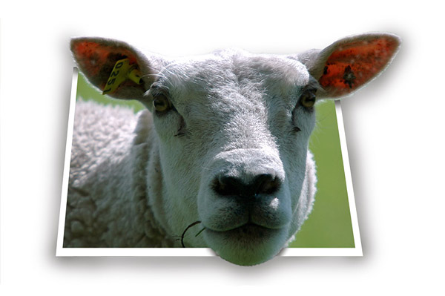
Animals that eat OTHER ANIMALS are called carnivorous. Carnivores that eat herbivores are called secondary consumers. Carnivores that eat other carnivores are called tertiary consumers.
Example: killer whales in an ocean food web ...
plankton → small fish → seals → killer whales
Here is another example of a food chain. The sun creates energy for the oak tree to make its own food. The oak tree is called a producer because it produces its' own food directly from the sun's energy. It makes acorns that the squirrel eats.

The squirrel is herbivorous because it eats only seeds, plants, and nuts. The fox is carnivorous, or a meat-eater, and it eats the squirrel.

Herbivores and carnivorous animals are both consumers because they eat other living things to get their energy. A decomposer is

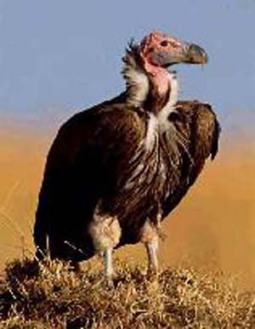
something that eats non-living things. After the fox dies, bacteria will help it decompose. A vulture is a scavenger, or a decomposer.

Food chain exercises

1. Fill in the blanks of the text with the following words. One of them does not match.

Producer herbivorous consumer buffalo

2. Define the following words:

food chain producer consumer decomposer herbivorous

carnivorous secondary consumer tertiary consumer

3. Create three food chains following the structure in the example.

Example: Sun --> Oak Tree --> Squirrel -->Fox--> Bacteria

The sun produces energy. The oak tree uses the sun energy to produce its own food. The squirrel eats the acorns. The fox eats the squirrel.

4. Match the name of the animals in the list below to the following categories. Example: panther

producer

consumer panther

decomposer
herbivorous

carnivorous panther

omnivorous

secondary consumer panther

tertiary consumer

predator

1.grass 2. flying squirrel 3. gorilla 4. zebra 5.deer 6. koala 7.grass 8. wolf 9. mouse 10. fox 11. snake 12.shark 13. almond 14.tree 15.killer whale 16. lettuce 17.salmon 18.bear 19.eagle 20.sheep 21. human 22.elephant 23. lion 24.chimpanzee 25. oak tree

