NAME____________________________________DATE_____________

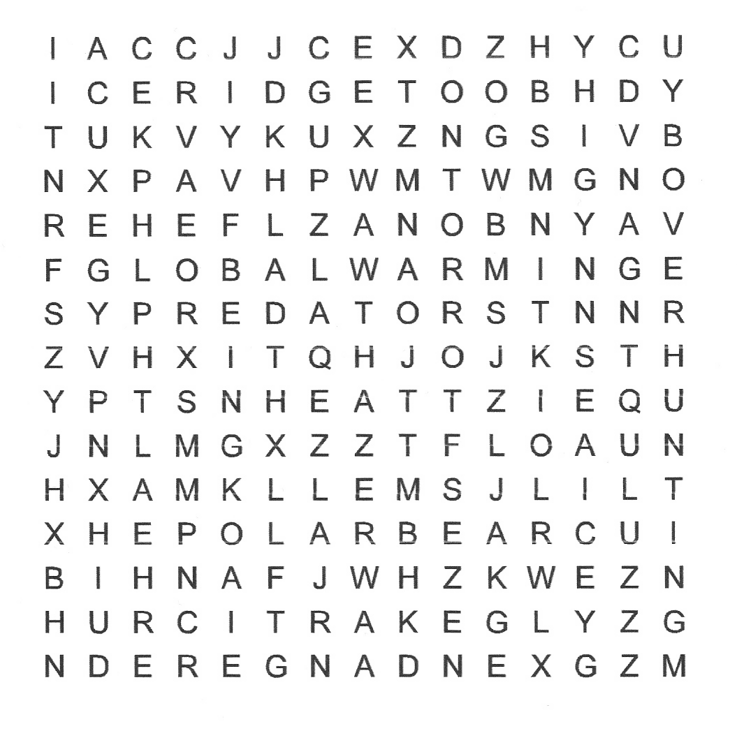
Artic Animals

Look for the following words in this word search

Artic
Health
Over-hunting
Sea ice
Endangered
Heat
Polar bear
Smell
Global-warming
Ice ridge
Predators

Look for these words in your dictionaries. Is there any word that does not appear? Which?

