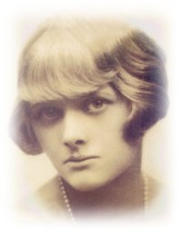
Rebecca by Daphne du Maurier

About the author

- Where and when was Daphne du Maurier born ?

- How did she spend her youth ?

- Where did she spend most of her life ?

- When did she die ?

- What was her father’s name and job?

- What was her mother’s name and job ?

- Who was her husband ?

- What were her children’s names ?

- Explain the duality of her personality.

- What is the explanation she gives for it ?

- Which noble title was she given in 1969 ?

About her work

- When did she begin writing stories ?

- What was her first novel ?

- Which country inspired her novels ?

- What genre were her novels ?

- Which writers influenced her ?

- Which fact about herself did Du Maurier believe to be the demon which fueled her creative life as a writer ?

- What is considered to be Daphne du Maurier’s masterpiece ?

- Write down the names of six of her novels which were adapted for the screen.

- Write down the names of three terror novels.

- How many plays did she write ? Write their titles.

About Rebecca

- Write the opening sentences of the original Rebecca novel written by Daphne du Maurier

- What is Manderley ?

- What places inspired Daphne du Maurier to create Manderley ?

- When was the novel started?

- When was it published ?

- Where was Daphne du Maurier when she started writing the novel?

- What is one of the main themes in the novel ?

- Compare Rebecca to Cinderella.

- Explain the different interpretations of the Rebecca-Maxim-narrator triangle.

- Explain the similarities between the characters in the novel and their relationships and the people in the author’s life.

- Why do you think the second Mrs. de Winter had no name ?

- Look for different covers from the different editions of the novel Rebecca by Daphne du Maurier. Copy four of them here. Describe them and explain why you have chosen them and how they are related to the novel.

Resources

http://www.fantasticfiction.co.uk/d/daphne-du-maurier/

http://www.dumaurier.org/index.html

http://en.wikipedia.org/wiki/Daphne_du_Maurier

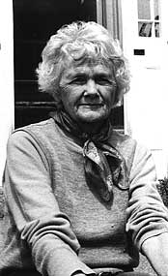
http://images.google.es/images?q=rebecca+dapne+du+maurier+covers&gbv=2&ndsp=20&svnum=10&hl=es&start=0&sa=N

