TODAY I AM GOING TO LEARN

1-

2.

3.

4.



TODAY I AM GOING TO SAY

STUDENT
TO
STUDENT
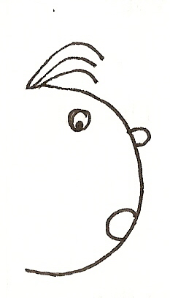
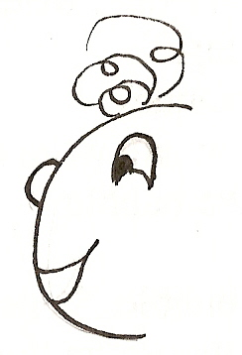

TO

STUDENT
TEACHER
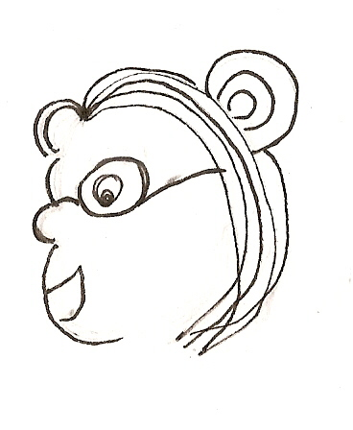

TEACHERS NOTES

LEARNING INTENTIONS

 | CONTENT | LANGUAGE |  | ATTITUDE
 |  | STUDENT TO STUDENT | STUDENT TO TEACHER
UNIT 1

UNIT 2

