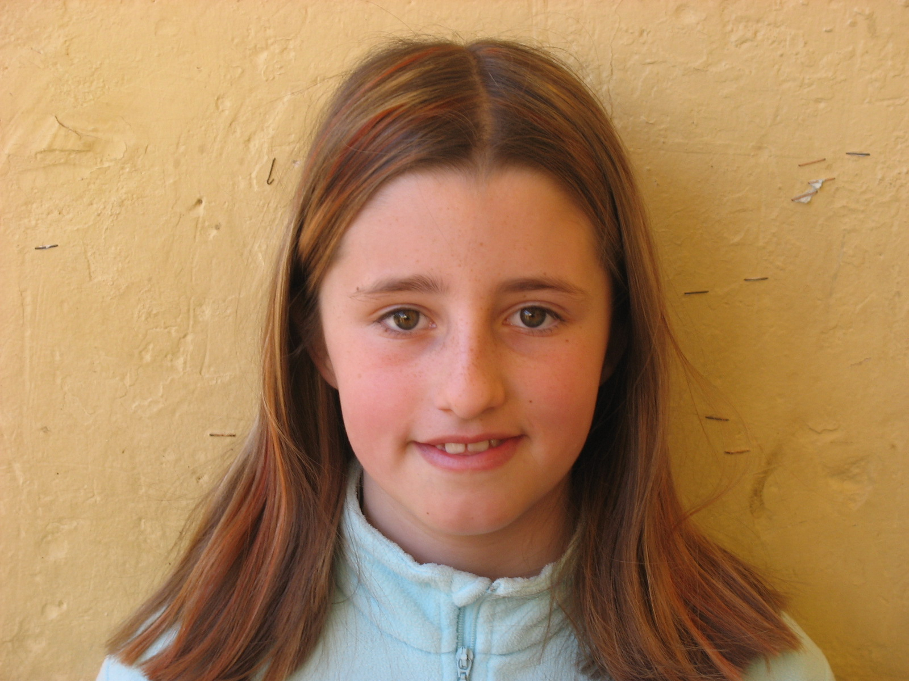
Hello. My name is Cristina. I’m 10 yers old. I lives in Vinyoles. Ihave 1 brother. I go to CEIP comtes lacambra school and I am in 5th level.

My favorite subject is art and PE. My phone number is 938595548. My email address is floc_cristina_22@hotmail.com. My favorite color is purple and black. My favorite sport is swiming and my favorite number is 4.

