Hello my name is Doraemon. An you name?
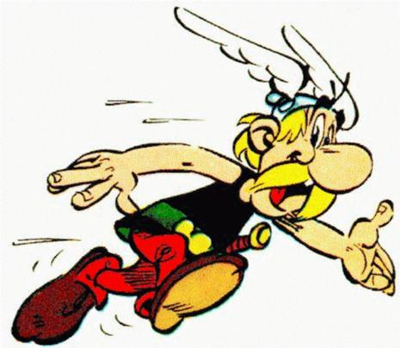
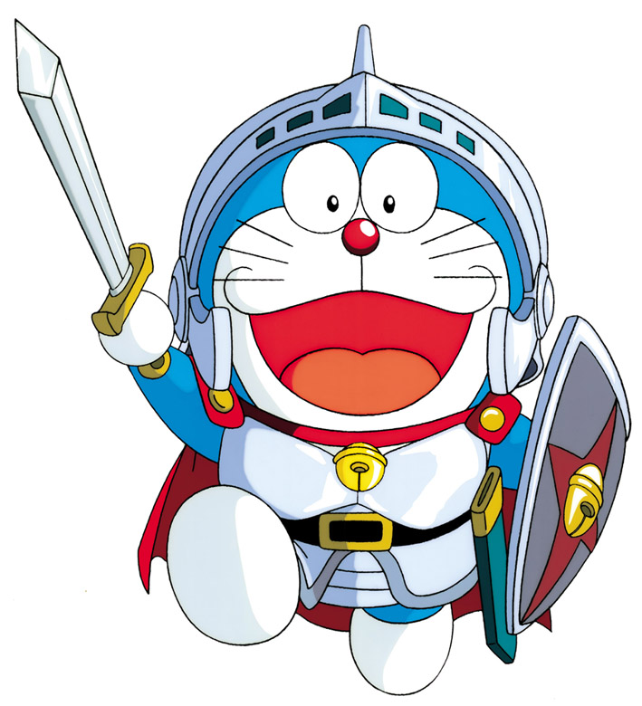

I am esterics
It’s a piglet?

No, it isn’t.
I am a cosmic cat!!

Im Sakura.
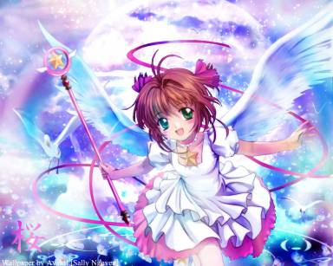
Hello I am Ompu.
And you?

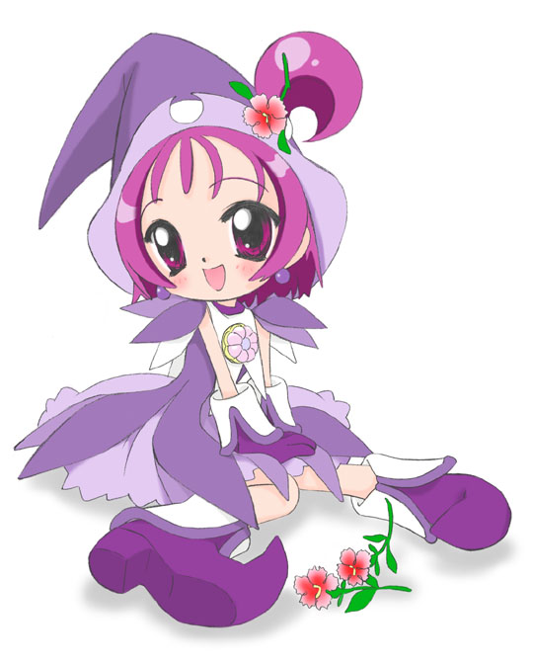

We are doing magic Tricks!

