UNIT 9: MERRY CHRISTMAS!
Worksheet 9

- Exercise 1:
1st. Design a Christmas card on paper

2nd. Create a new document called “Christmas card”

3rd. Think about the layout of the page:
portray (vertical)

or

landscape (horitzontal)

4th. Divide the page in two columns using the sign:

or go to Formato-Columnas

5th. Think about the design to fold the paper.

6th. Insert a picture or a framework

7th. Copy the wish you have written in a text box.

7th. Save it, print it and give it to your family.

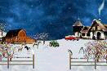
MERRY CHRISTMAS

I wish you
Peace and love for ever!

jordi

Let’s talk together!

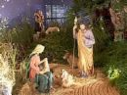

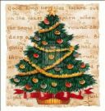
Look at these images and say if you think they come from Catalonia, Spain , Great Britain or Norway:
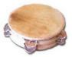


We think | Christmas tree | is from | Catalonia
We think | Santa Claus | is from | Spain
We think | el pessebre | is from | Great Britain
We think | the tambourine | is from | Norway
We think | the sleigh | is from

We think (the) ................ is from ......................

Do you agree?
No, we don’t agree , we think (the) ................ is from ...................

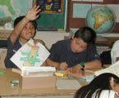



Do you know more Christmas images form these countries? :

- Catalonia?
- Spain?
- Great Britain?
- North countries?
- Marroco?
- Africa?

(after some ideas , search in internet: Images of Christmas in different countries)

What do you think the real images should be? Why?

