UNIT 1: WHAT DOES COMPUTER MEAN?
Worksheet 1


The parts of a computer are known as the hardware.

* Exercise 1: Look at this diagram of a computer. Click in the text box and type in the names for the parts of the computer:

- Keyboard
- Monitor
- Power unit

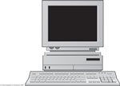

Exercise 2: Write the names under the picture:
a)A printer c) mouse e) loudspeakers
b)A scanner d) microphone f) laptop
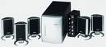 | 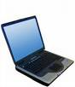 | 
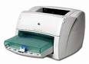 | 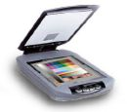 | 