

UNIT 6: BE A SCIENTIST

WORKSHEET 6 a

Exercise 1: Type the text in a new document called “Be a scientist”
Exercise 2: Justify the text.
Exercise 3: Highlight and put in bold the important words to understand the text
Exercise 4: Look up these words in a dictionary on line and translate the text into Catalan.

THE DESERT
If the rainfall in an area is less than 25 cm a year, then the land is called a desert. A typical desert is very dry with extreme temperatures. Days are hot and nights are cold. The landscape consists of sand or rock. Few animals can survive here, and many are only active at night when it is cooler. Some have to get the water they need from their food.
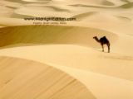
The biggest desert in the world is the Sahara in Africa.

UNIT 6: BE A SCIENTIST

WORKSHEET 6 b

Exercise 3: Highlight and underline the main ideas of these two texts .

WHALES

Whales are mammals. They are very big and grey. There are different type of whales. The most common are the grey whales. They have a big body and a very strong fin . They live in the sea. They prefer cold waters. They eat smaller fish and they can swim very well.

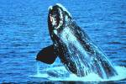
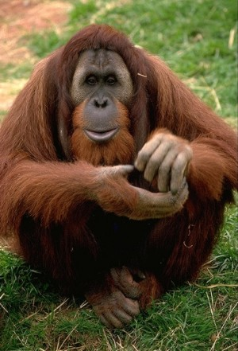
ORANGUTAN

I’m a lot like you. Look how I take the things with my hands. I can also walk like you, but my feet are more useful than yours. They work like an extra pair of hands. We’ve got other things in common too, they sleep in a bed but they build a new one every night!

