
UNIT 18: DO YOU LIKE THIS Cd rom?

1st. Talk about CDs at school:

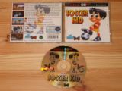
- What are they about?
- Do you think you will like them? Why?
- Talk about CDs you have at home?
- Are they good, useful, educational?
- Why do you like them?
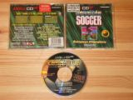
- Are they bad, not respectful with others, use bad language, show bad actions, etc?

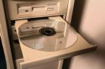
2nd. Choose a CD from school and use it for 20 minutes .

3rd. Describe your Cdrom and give your opinion about it to the rest of the class and fill the register of CDs you started in the first term
We used “ ........”.
It is about..........
We like it because it is very.......
We don’t like it because it is a little.....

4th. Finally, add the cd rom in the register chart you started in the first term.

