
UNIT 10: TAKE ME A PHOTO!

ZOOM
BUTTON ON/OFF
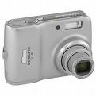
FLASH
LENS
BATTERIES AND CARD

1ST. Take a photo of your friend (his/her face and breast)

2nd. Download it on the computer following your oral teacher’s instructions.

3rd. Create a new document in your ICT folder and name it.

4th. Insert your photo.

5th Save the document as a .jpg document.

