
UNIT 13: MY FAVOURITE COMIC IS...

Talk to your teacher:
What comics do you know?
I know...
What comics do you read?
I read...
What is your favourite comic character?
Why?

I like ..............................
Because he is good/brave/strong/funny/
beautiful

Look at some comics from the school library or from home and talk about good and bad characters.
Good characters | Why...? | Bad characters | Why?
Asterix | Because he is intelligent | Gargamel | Because he wants to eat the “Barrufets”

Now you can do this activity:

1st. Go to google and search comic characters in internet.

2nd. Copy and paste them on a document.

3rd. Make them talk or think using callouts in autoshapes=autoformas

5th. Use as many characters as you want: good or bad.

6th. Save it , give it a name and print it in black and white.

Look at this:
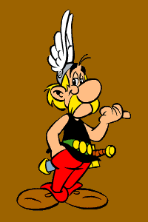
Can you find me in the web?

