TRICK OR TREAT

Walking down the streets,
Knocking on the doors,
Wearing a fancy dress,
Looking for a ghost.

Bells in doorways ring,
Happy pumpkins smile,

Oh what fun it is to sing

and get some sweets tonight!

Trick or treat, trick or treat,
Trick or treat we say!
Try to get the treats before the witch takes us away!

Trick or treat, trick or treat,
Trick or treat we say!

If you don’t have treats for usss We don’t go away!

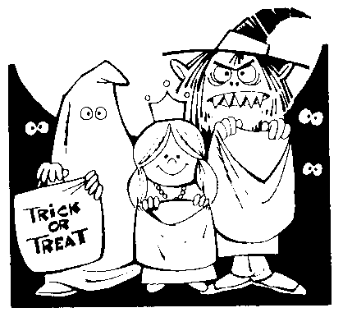
(Adapted from Jingle Bells).

