TRICK OR TREAT (Adaptada de Jingle Bells)

Walking down the streets,
Knocking on the doors,
Wearing a __________,
Looking for a __________.

Bells in doorways ring,
Happy ________ smile,

Oh what fun it is to sing

and get some ________ tonight!

Trick or treat, trick or treat,
Trick or treat we say!
Try to get the treats before
the ________ takes us away!

Trick or treat, trick or treat,
Trick or treat we say!

If you don’t have ________ for us

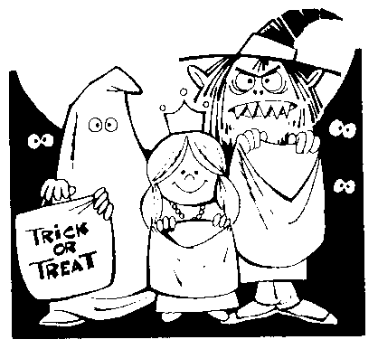
We don’t go away!

