12. My room What can I do? Speaking

12.1 Individual work. Read Raul’s room description and answer the following questions
My room is very big and lightly. It has got two beds, one desk, a big wardrobe and a small table next to my bed. The walls are light blue and the carpet is green. There is a big window between the wardrobe and the door. There are some posters on the walls. My favourite one is the poster of Pau Gasol. He is the best!!  There are many things on the desk. The computer is on the left, and next to it there are some pencils, pens and papers. The books are on the shelf, above the desk, and there is also a small lamp. There are some drawers under the desk where you can find anything: rubbers, notebooks, sharpeners, markers, colours, socks….. There are also balls, games, caps and pillows on the floor. My mother is always very angry with me because I don’t tidy my room. But I love my room! | 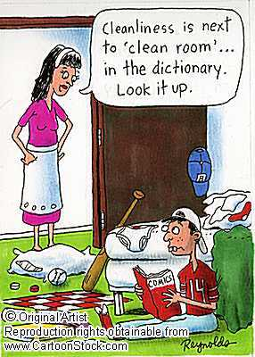

12.2 Write the name of the objects in Raul’s room which you can find in your own room:
___________________________________________________________________
___________________________________________________________________
___________________________________________________________________

12.3 Write the name of 5 objects in your room which are not mentioned in Raul’s description.
___________________________________________________________________
___________________________________________________________________
___________________________________________________________________

12.4 Explain where these 5 objects are using different prepositions:
e.g: “The alarm clock is behind the bed”
-- _________________________________________________________________
-- _________________________________________________________________
-- _________________________________________________________________
-- _________________________________________________________________
-- _________________________________________________________________

12.5 Use the information in exercises 2, 3 and 4 and describe your room using as many sentences as possible (don’t show it to your partners). Then, draw this room.

- - - - - - - - - - - - - - - - - - - - - ----- - -- - - -- - - - - - -- - - - -- - - - -- - - - - - - - -- - - - -- -

10.6 Draw your room

12.6 Group work. Give both the description and the drawing to your teacher. He/she will distribute them into your partners. You will get a drawing and a description which are not yours. You have to go round the class and find the pairs. Keep the description, give the drawing.

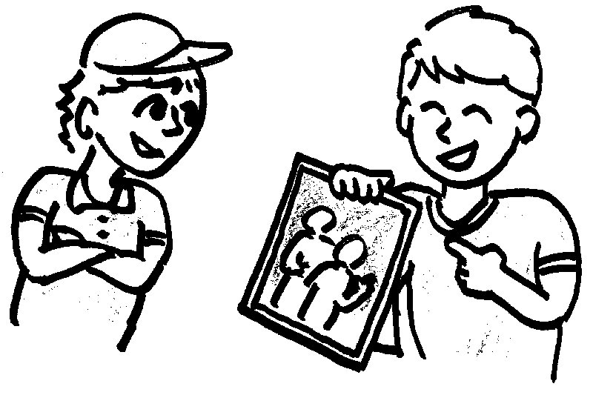 | - Has your bedroom got a desk?  - yes, it has  - Is your bedroom big?  - sorry, it isn’t  - Is there a lamp on the desk?  - yes, there is
12.7 Find out who has got the description and drawing of your own room. Describe it to your colleagues in order to find it.

Eg: My room is big. It is very untidy. It has got two beds…. etc Have you got my room?

12.8 Pair work. Work in pairs and try to improve your descriptions. Have a look at the words and expression in bold in Raul’s description

Are there any spelling mistakes?
Are there some prepositions?
Are there some adjectives?
Are the adjectives before the noun?
Have all the sentences got a subject?
Have you used “there is” and “there are”?
Have you used “some” and “any”?

Rewrite your description, read it aloud and tape it. We will upload it in the next article of your blog.
My room .....

12-9. Go to the teacher’s blog “My Room” and follow her instructions. You will upload the recording of the description and will listen to the descriptions of other students.

* To listen to some examples of students describing their room and to read some comments written by other students who have listened to that description go to:

Lena: http://classblogmeister.com/blog.php?user_id=107344&blogger_id=140074
Adai: http://classblogmeister.com/blog.php?user_id=107344&blogger_id=140067

