HOMEWORK
Give you vectors
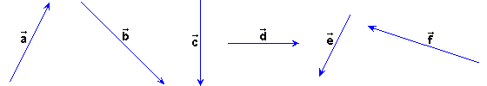
Do the next sums:

+ | + | +
+ | + | +
+ | +

