HOMEWORK
Give you the same vectors that in the previous activity
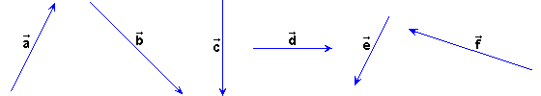
Using now the parallelogram law, do the next sums of the previous activity.

+ | + | +
+ | + | +
+ |  | +

