HOMEWORK
Give you the same vectors that in the previous activity
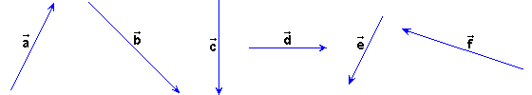
Do the next sums:

1) (+) + and + (+). Check that the result is the same.
2) (+) + and + (+). Check that the result is the same.

