HOMEWORK
Give you the next vectors that in the previous activity
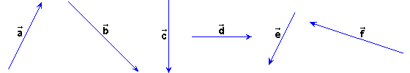
Do the next sums:

1) ++ and ++. Check that the result is the same.
2) ++ and ++. Check that the result is the same.

