HOMEWORK
Give you the same vectors that in the previous activity
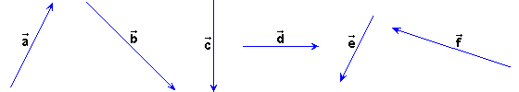
Do three constructions like in the interactive activity to get the next sums and subtractions:
1) +, -+, - and -- | 2) +, -+, - and --
3) +, -+, - and --

