HOMEWORK
Give you vectors
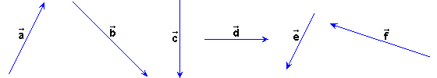
Draw the next vectors:

2 | 0.5
1.5 | - 3
1.75 | 0.4

