HOMEWORK
Give you vectors | 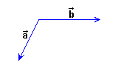
Applying the parallelogram law draw the vectors,, and , being

= 3+ 2 | = - 2+
= - 4- 1.5 | = 2- 3

