HOMEWORK
Give you vectors | 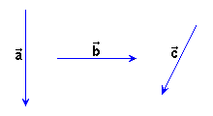
Draw the next vectors:

= 1.5+ 2+ 1.75 | = 3 - 1.5+ 3.25

