HOMEWORK
Give you vectors | 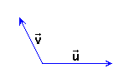
Make three constructions that show next equalities:

1) 3(+) = 3+ 3
2) - 2(+) = - 2- 2
3) 1.5(+) = 1.5+ 1.5

