HOMEWORK
Given six vectors
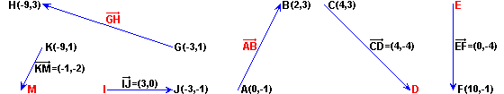
Calculate:
a) Components of the vector

b) Coordinates of point D

c) Coordinates of point E

d) Components of the vector

e) Coordinates of point I

f) Coordinates of point M

