HOMEWORK

Being A(a₁,a₂) and B(b₁,b₂), and now you suppose that you want to divide segment AB in five equal parts by the points P₁, P₂, P₃ and P₄. Show that these four points can get from the formulas: | 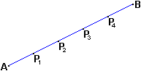
and

