HOMEWORK

Give you three vectors , and of figure,  with || = 6, || = 4 and || = 5. | 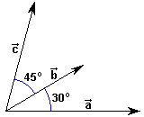

Calculate scalar products:

a) ·(+)

b) (-)·

c) 2·(3+4)

d) (+2)·(-3)

