HOW TO MAKE A CARVED PUMPKIN

You need:  1 short, sharp knife  1 dessert spoon  1 teaspoon  1 candle or tea-light  Plenty of newspaper to protect work surface  Large bowl for pumpkin seeds and flesh | 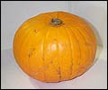
Step One:  Cut a circular hole around the stalk.  Tilt the point of the knife into the centre of the pumpkin.  This will stop the lid from falling in. | 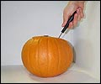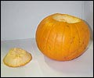
Step Two: Scoop out the seeds and any loose flesh using the dessertspoon and the knife if needed. | 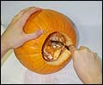
Step Three: Sketch the face onto your pumpkin. Use a biro so any mistakes can be scrubbed off with a scouring pad or fingernail. | 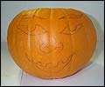
Step Four: Carefully cut out the features. Take small cuts and use a puncturing motion rather than a slicing one. | 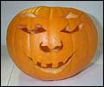
Step Five: Gently scrape away the flesh on the inside of the face until it is only 1cm thick. | 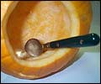
Step Six: Using the knife, mark a circle the size of your candle or tea-light in the centre of the base. | 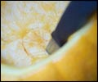
Step Seven: Carefully hollow out the marked area with the teaspoon. | 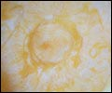
Step Eight: Place your candle in the hollow, light it and replace the lid of your jack-o'-lantern. | 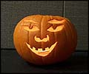
Preserving your pumpkin: A shrivelled manky pumpkin isn't going to impress anyone.
If you need to preserve your creation, put it in the fridge. Maybe wrapped in clear food wrap, if you can be bothered.

