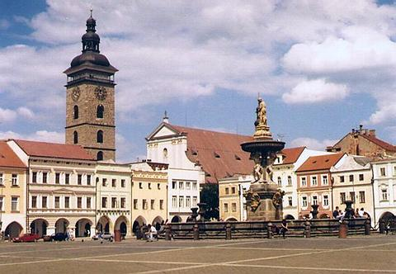
České Budějovice

Bohemia King Přemysl Otakar II chaose the confluence of the large Sout Bohemian Revers Vltava and Malše in 1265 to found the city of České Budějovice to strengthen his positron of power in South Bohemia. České Budějovice is well-now for its the larges square in Modele Europe. In the modele of a square is a fountain. There are benches, too. You can have a rest on these benches.

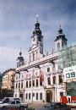

Next to the square is „ČERNÁ VĚŽ“. It was foun in 1577. Earlier it used like belfry. It has got 72,29 meters.

On the square is TOWN HALL- It´s very beautiful build. It has got blue color. I tis decorated monuments. In town hall work chief magistráte.

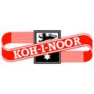

KOH-I-NOOR HARDTMUTH
Koh-i noor hardtmuth is very favorite company logo in the Czech Republic.Their products are comfortable and very good for writting.They produces everything for writting.


BUDĚJOVICKÝ BUDVAR
Budějovický Budvar is the name of czech beer.It is very good.

