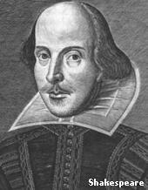
Famous people

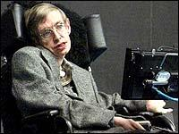

What famous people are there in Britain? Let’s know some of them.

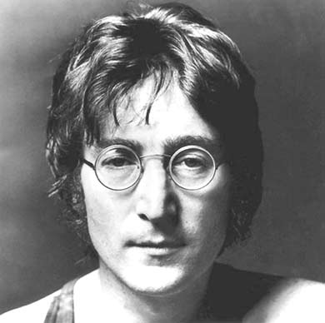
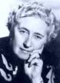
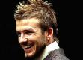

⬥ Who are they? (Famous writers)

He worked as a professor at the University of Oxford. He wrote “The Lord of the Rings”
She is the world’s best known mistery writer. She wrote “Murder on the Orient Express”
He wrote some of the most popular novels of the 19th century: “Oliver Twist”, “Tales of two cities”...
He was a playwright and poet. He wrote a lot of plays: “As you like”, “Romeo and Juliet”...

⬥ Who are they? (Famous scientists)

He was a naturalist of the 19th century. He developed the Theory of Evolution.
He was the scientist who formulated the Theory of Universal Gravitation
He was a bacterioligish who discovered penicillin in 1928
He is a physicist noted for his research into the origin of universe. His work influences the developament of the Big Bang Theory.

⬥ Who are they? (Famous singers and musicians)

He was a member of the Beatles, the biggest rock band in the 60’s.
She is a British singer, originally in the girl band the Spice Girls, where she was known as Posh Spice.
He is an English musician and formerly bassist and lead singer of The Police.
He was a singer and the lead vocalist of the British rock band Queen.

⬥ Who are they? (Famous footballers)

He is an English football player. He plays as a striker, and is noted particularly for his speed and acceleration. He plays for Real Madrid since 2004.
He was a Northern Irish football international who is mainly remembered for his time with Manchester United F.C. He died in 2005.
He is a successful English footballer. He was born in Newcastle and currently plays for Newcastle United.
He is a midfielder for Real Madrid and captain of the English national team. He is noted for his marriage to a Spice Girl..
⬥ Who are they? (Famous politicians)

She was the first woman Prime Minister of the United Kingdom, a position she held from 1979 to 1990.
He was the Prime Minister of the United Kingdom during World War II. At various times an author, soldier, journalist, legislator and painter, he is generally regarded as one of the most important leaders in British and world history.
He is the present Prime Minister

⬥ Who are they? (Famous royalty)

He is famous for having been married six times
She was Queen of the United Kingdom of Great Britain and Ireland from 20 June 1837, and Empress of India from 1 January 1877 until her death. Her reign lasted more than sixty-three years, longer than that of any other British monarch.
From the time of her marriage to the Prince of Wales in 1981 until her death in a car accident in Paris in 1997, she was one of the world's most famous celebrities.

⬥ Which is your favourite British celebrity? Why?

(Do this activity on a new document. You can also look for a photo of the person, copy and paste it on the document. Print it)

